**Time Travel :-**

**Data Protection Life Cycle**

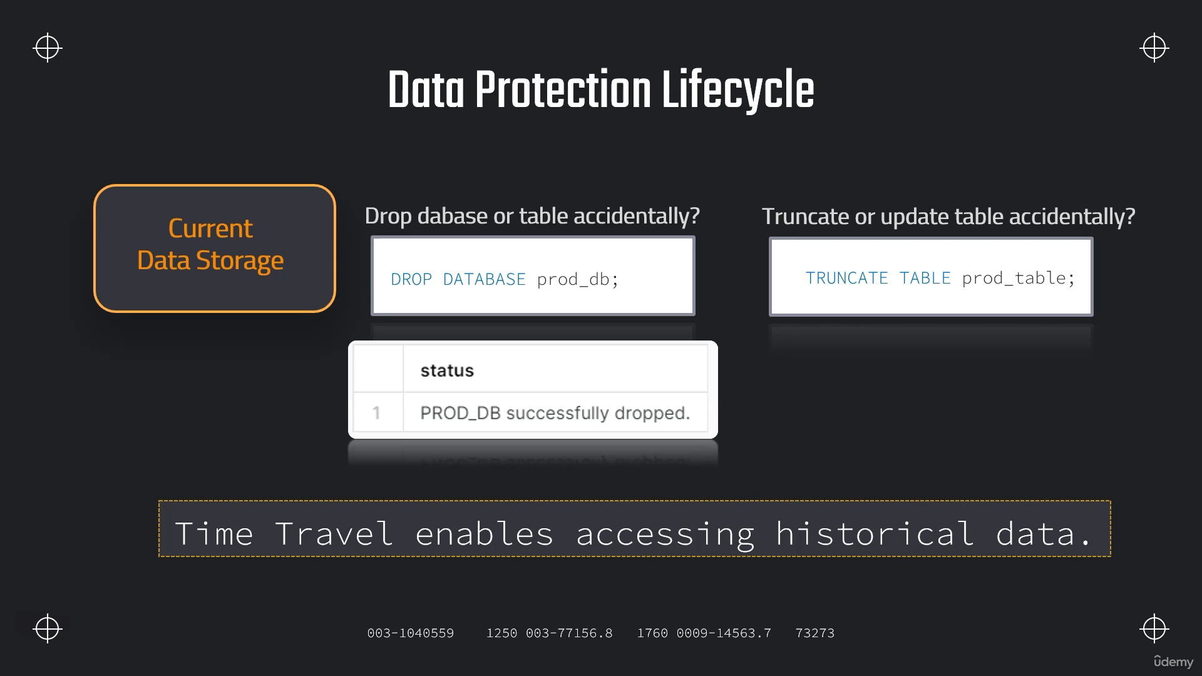

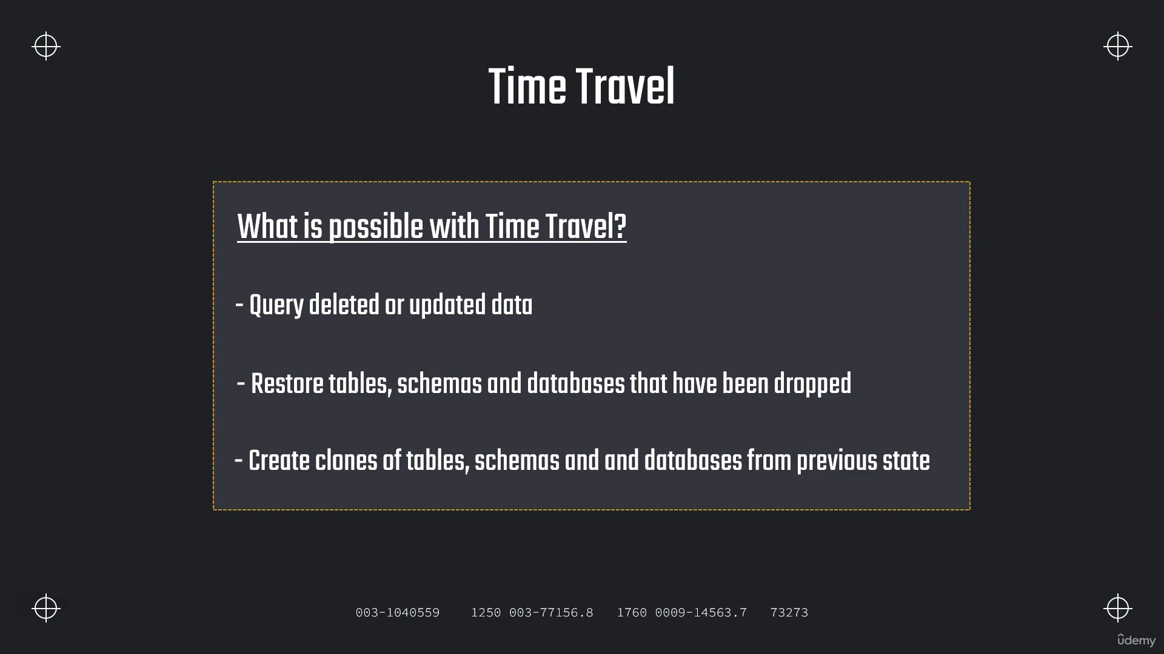

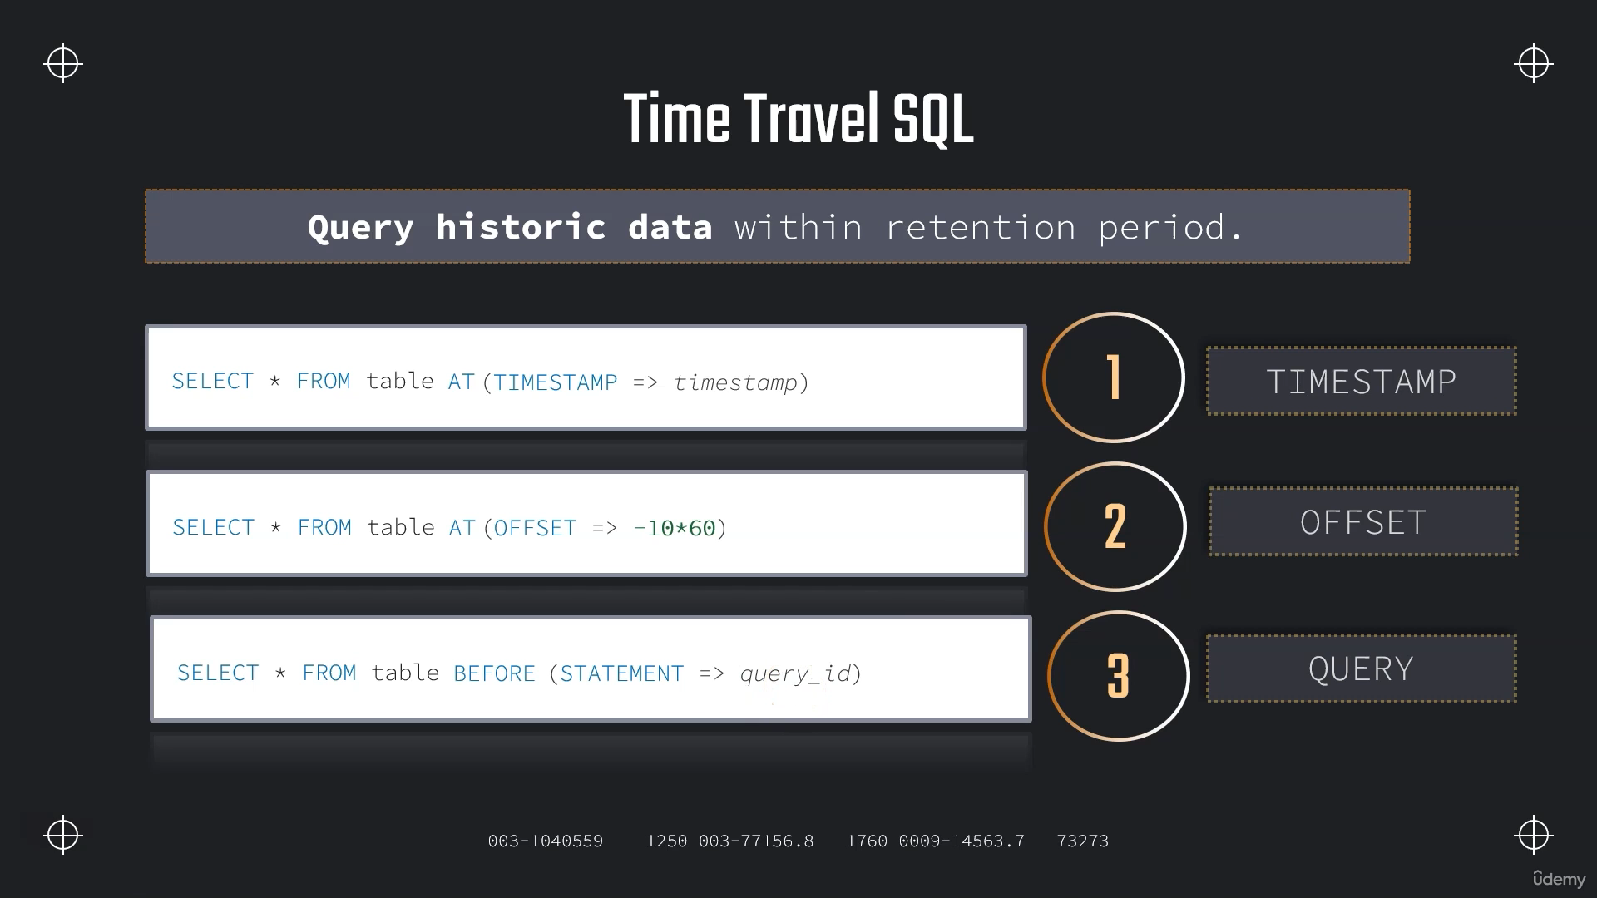

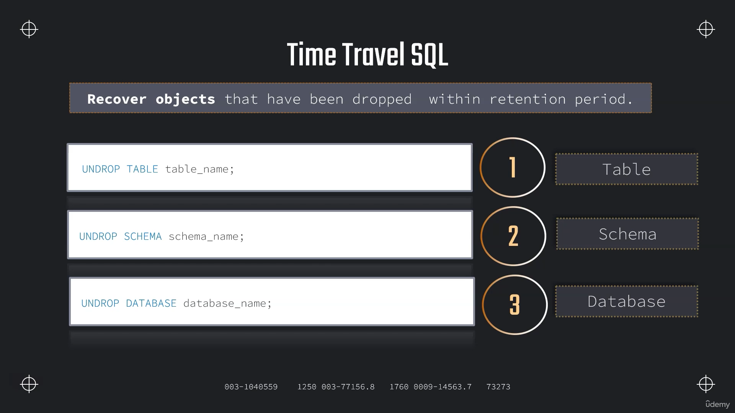

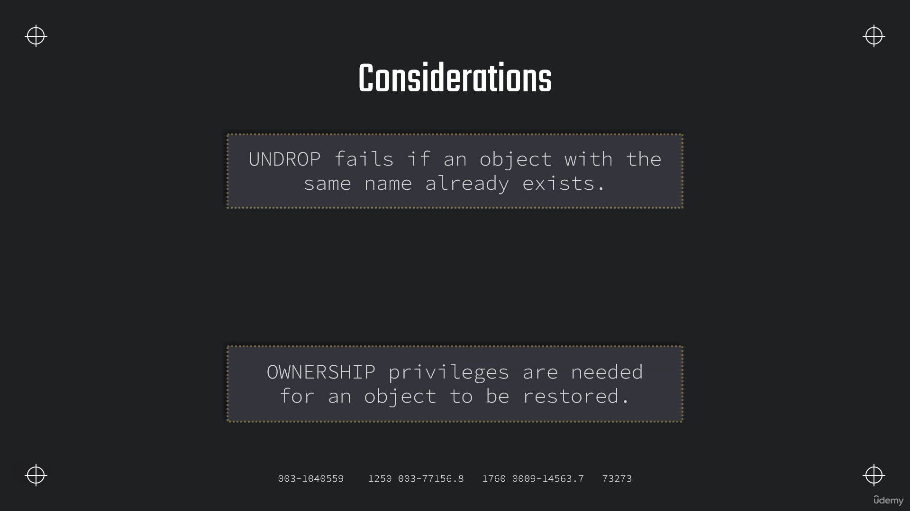

**Using Time Travel**

**// Setting up table**

**CREATE OR REPLACE TABLE OUR_FIRST_DB.public.test (**

**id int,**

**first_name string,**

**last_name string,**

**email string,**

**gender string,**

**Job string,**

**Phone string);**

**CREATE OR REPLACE FILE FORMAT MANAGE_DB.file_formats.csv_file**

**type = csv**

**field_delimiter = ','**

**skip_header = 1;**

**CREATE OR REPLACE STAGE MANAGE_DB.external_stages.time_travel_stage**

**URL = 's3://data-snowflake-fundamentals/time-travel/'**

**file_format = MANAGE_DB.file_formats.csv_file;**

**LIST @MANAGE_DB.external_stages.time_travel_stage;**

**COPY INTO OUR_FIRST_DB.public.test**

**from @MANAGE_DB.external_stages.time_travel_stage**

**files = ('customers.csv');**

**SELECT * FROM OUR_FIRST_DB.public.test;**

**// Use-case: Update data (by mistake)**

**UPDATE OUR_FIRST_DB.public.test**

**SET job = 'a' ;**

**// // // Using time travel: Method 1 - 2 minutes back**

**SELECT * FROM OUR_FIRST_DB.public.test at (OFFSET => -60*3.5);**

**// // // Using time travel: Method 2 - before timestamp**

**SELECT * FROM OUR_FIRST_DB.public.test before (timestamp => '2025-01-03 16:5:50.581'::timestamp);**

**-- Setting up table**

**CREATE OR REPLACE TABLE OUR_FIRST_DB.public.test (**

**id int,**

**first_name string,**

**last_name string,**

**email string,**

**gender string,**

**Job string,**

**Phone string);**

**COPY INTO OUR_FIRST_DB.public.test**

**from @MANAGE_DB.external_stages.time_travel_stage**

**files = ('customers.csv');**

**SELECT * FROM OUR_FIRST_DB.public.test;**

**2025-01-03 11:29:46.994 +0000;**

**-- Setting up UTC time for convenience;**

**ALTER SESSION SET TIMEZONE ='UTC';**

**SELECT DATEADD(DAY, 0, CURRENT_TIMESTAMP);**

**UPDATE OUR_FIRST_DB.public.test**

**SET Job = 'Data Scientist';**

**SELECT * FROM OUR_FIRST_DB.public.test;**

**SELECT * FROM OUR_FIRST_DB.public.test before (timestamp => '2025-01-03 11:29:46.994 +0000'::timestamp);**

**// // // Using time travel: Method 3 - before Query ID**

**// Preparing table**

**CREATE OR REPLACE TABLE OUR_FIRST_DB.public.test (**

**id int,**

**first_name string,**

**last_name string,**

**email string,**

**gender string,**

**Phone string,**

**Job string);**

**COPY INTO OUR_FIRST_DB.public.test**

**from @MANAGE_DB.external_stages.time_travel_stage**

**files = ('customers.csv');**

**SELECT * FROM OUR_FIRST_DB.public.test;**

**// Altering table (by mistake)**

**UPDATE OUR_FIRST_DB.public.test**

**SET EMAIL = null;**

**SELECT * FROM OUR_FIRST_DB.public.test;**

**SELECT * FROM OUR_FIRST_DB.public.test before (statement => '019b9ee5-0500-8473-0043-4d8300073062');**

**Assignment :**

**USE ROLE ACCOUNTADMIN;**

**USE DATABASE DEMO_DB;**

**USE WAREHOUSE COMPUTE_WH;**

**CREATE OR REPLACE TABLE DEMO_DB.PUBLIC.PART**

**AS**

**SELECT * FROM "SNOWFLAKE_SAMPLE_DATA"."TPCH_SF1"."PART";**

**SELECT * FROM PART**

**ORDER BY P_MFGR DESC;**

**ALTER SESSION SET TIMEZONE ='UTC';**

**SELECT DATEADD(DAY, 0, CURRENT_TIMESTAMP);**

**2025-01-03 14:35:33.105 +0000;**

**01b9774b-030b-d1e9-000a-7df7000293e6;**

**UPDATE DEMO_DB.PUBLIC.PART**

**SET P_MFGR='Manufacturer#CompanyX'**

**WHERE P_MFGR='Manufacturer#5';**

**----> Note down query id here:**

**SELECT * FROM PART**

**ORDER BY P_MFGR DESC;**

**SELECT * FROM DEMO_DB.PUBLIC.PART at (OFFSET => -60*5.5) ORDER BY P_MFGR DESC;**

**SELECT * FROM DEMO_DB.PUBLIC.PART before (statement => '01b9774b-030b-d1e9-000a-7df7000293e6') ORDER BY P_MFGR DESC;**

**SELECT * FROM DEMO_DB.PUBLIC.PART before**

**(timestamp => '2025-01-03 14:35:33.105 +0000'::timestamp) ORDER BY P_MFGR DESC;**

**Restoring Data**

**// Setting up table**

**CREATE OR REPLACE TABLE OUR_FIRST_DB.public.test (**

**id int,**

**first_name string,**

**last_name string,**

**email string,**

**gender string,**

**Job string,**

**Phone string);**

**COPY INTO OUR_FIRST_DB.public.test**

**from @MANAGE_DB.external_stages.time_travel_stage**

**files = ('customers.csv');**

**SELECT * FROM OUR_FIRST_DB.public.test;**

**// Use-case: Update data (by mistake)**

**UPDATE OUR_FIRST_DB.public.test**

**SET LAST_NAME = 'Tyson';**

**01b97762-030b-d1e9-000a-7df70002947e ;**

**UPDATE OUR_FIRST_DB.public.test**

**SET JOB = 'Data Analyst';**

**01b97763-030b-d1e9-000a-7df700029482;**

**SELECT * FROM OUR_FIRST_DB.public.test before (statement => '01b97763-030b-d1e9-000a-7df700029482');**

**// // // Bad method**

**CREATE OR REPLACE TABLE OUR_FIRST_DB.public.test as**

**SELECT * FROM OUR_FIRST_DB.public.test before (statement => '01b97763-030b-d1e9-000a-7df700029482');**

**SELECT * FROM OUR_FIRST_DB.public.test;**

**CREATE OR REPLACE TABLE OUR_FIRST_DB.public.test as**

**SELECT * FROM OUR_FIRST_DB.public.test before (statement => '01b97763-030b-d1e9-000a-7df700029482');**

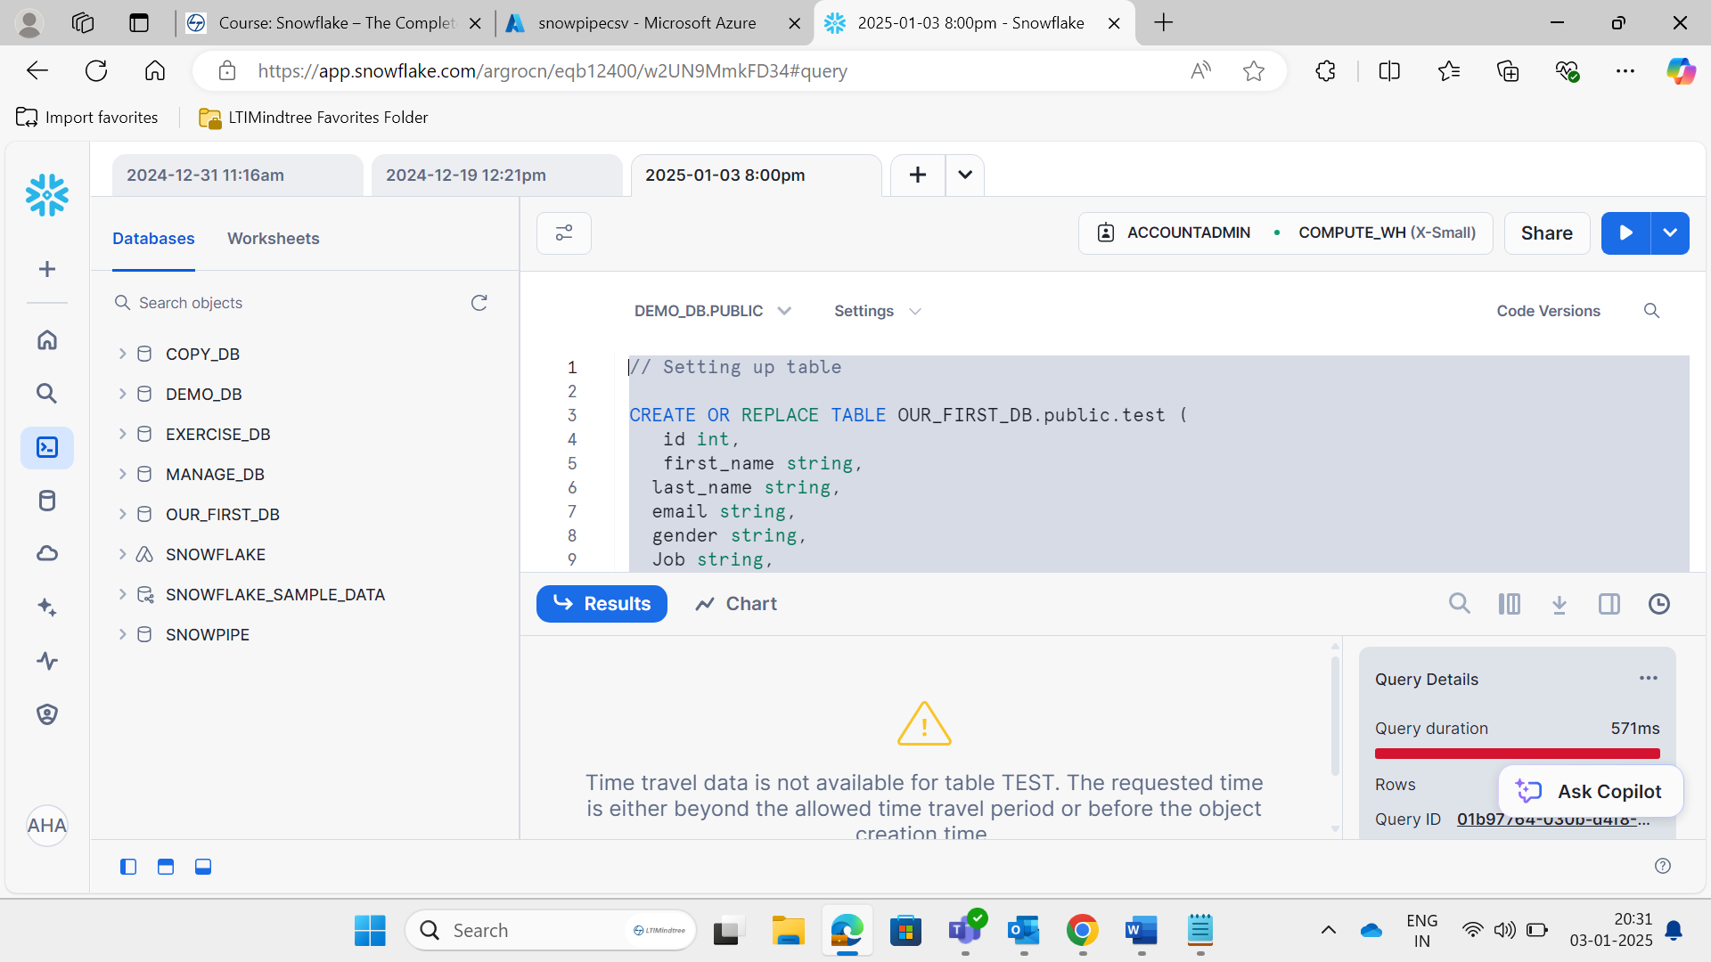

**// // // Good method**

**01b97767-030b-d97a-000a-7df7000351fa;**

**CREATE OR REPLACE TABLE OUR_FIRST_DB.public.test_backup as**

**SELECT * FROM OUR_FIRST_DB.public.test before (statement => '01b97767-030b-d97a-000a-7df700035202');**

**TRUNCATE OUR_FIRST_DB.public.test;**

**INSERT INTO OUR_FIRST_DB.public.test**

**SELECT * FROM OUR_FIRST_DB.public.test_backup;**

**CREATE OR REPLACE TABLE OUR_FIRST_DB.public.test_backup as**

**SELECT * FROM OUR_FIRST_DB.public.test before (statement => '01b97767-030b-d97a-000a-7df7000351fa');**

**TRUNCATE OUR_FIRST_DB.public.test;**

**INSERT INTO OUR_FIRST_DB.public.test**

**SELECT * FROM OUR_FIRST_DB.public.test_backup;**

**SELECT * FROM OUR_FIRST_DB.public.test ;**

**UNDROP TABLES ;**

**// Setting up table**

**CREATE OR REPLACE STAGE MANAGE_DB.external_stages.time_travel_stage**

**URL = 's3://data-snowflake-fundamentals/time-travel/'**

**file_format = MANAGE_DB.file_formats.csv_file;**

**CREATE OR REPLACE TABLE OUR_FIRST_DB.public.customers (**

**id int,**

**first_name string,**

**last_name string,**

**email string,**

**gender string,**

**Job string,**

**Phone string);**

**COPY INTO OUR_FIRST_DB.public.customers**

**from @MANAGE_DB.external_stages.time_travel_stage**

**files = ('customers.csv');**

**SELECT * FROM OUR_FIRST_DB.public.customers;**

**// UNDROP command - Tables**

**DROP TABLE OUR_FIRST_DB.public.customers;**

**SELECT * FROM OUR_FIRST_DB.public.customers;**

**UNDROP TABLE OUR_FIRST_DB.public.customers;**

**// UNDROP command - Schemas**

**DROP SCHEMA OUR_FIRST_DB.public;**

**SELECT * FROM OUR_FIRST_DB.public.customers;**

**UNDROP SCHEMA OUR_FIRST_DB.public;**

**// UNDROP command - Database**

**DROP DATABASE OUR_FIRST_DB;**

**SELECT * FROM OUR_FIRST_DB.public.customers;**

**UNDROP DATABASE OUR_FIRST_DB;**

**// Restore replaced table**

**UPDATE OUR_FIRST_DB.public.customers**

**SET LAST_NAME = 'Tyson';**

**UPDATE OUR_FIRST_DB.public.customers**

**SET JOB = 'Data Analyst';**

**// // // Undroping a with a name that already exists**

**CREATE OR REPLACE TABLE OUR_FIRST_DB.public.customers as**

**SELECT * FROM OUR_FIRST_DB.public.customers before (statement => '019b9f7c-0500-851b-0043-4d83000762be');**

**SELECT * FROM OUR_FIRST_DB.public.customers;**

**UNDROP table OUR_FIRST_DB.public.customers;**

**ALTER TABLE OUR_FIRST_DB.public.customers**

**RENAME TO OUR_FIRST_DB.public.customers_wrong;**

**DESC table OUR_FIRST_DB.public.customers;**

**UNDROP table OUR_FIRST_DB.public.customers;**

**SELECT * FROM OUR_FIRST_DB.public.customers;**

**CREATE OR REPLACE TABLE OUR_FIRST_DB.public.customers as**

**SELECT * FROM OUR_FIRST_DB.public.customers before (statement => '01b97774-030b-db3c-000a-7df700038072');**

**Assignment**

**CREATE DATABASE TIMETRAVEL_EXERCISE;**

**CREATE SCHEMA TIMETRAVEL_EXERCISE.COMPANY_X;**

**CREATE TABLE CUSTOMER AS**

**SELECT * FROM SNOWFLAKE_SAMPLE_DATA.TPCH_SF1.CUSTOMER**

**LIMIT 500;**

**SELECT * FROM CUSTOMER;**

**DROP SCHEMA TIMETRAVEL_EXERCISE.COMPANY_X;**

**SELECT * FROM CUSTOMER;**

**UNDROP SCHEMA TIMETRAVEL_EXERCISE.COMPANY_X;SELECT * FROM CUSTOMER;**

**Retention Time :-**

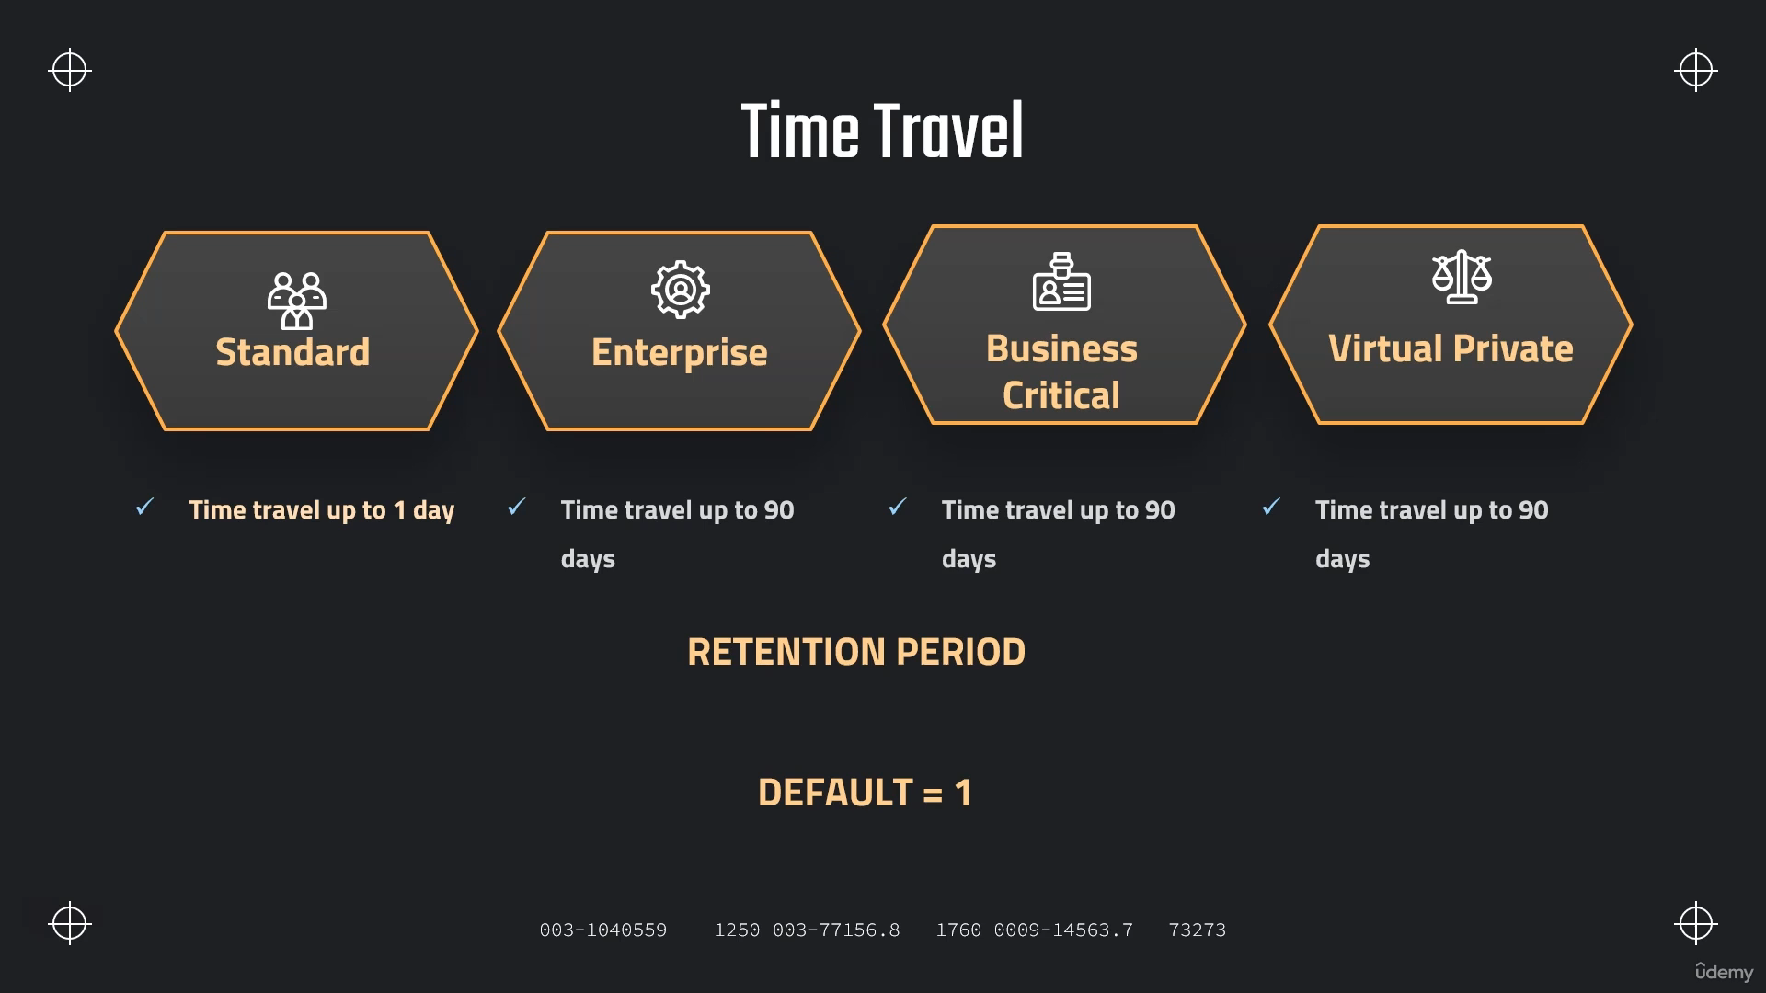

**SHOW TABLES like '%CUSTOMERS%';**

**ALTER TABLE OUR_FIRST_DB.PUBLIC.CUSTOMERS**

**SET DATA_RETENTION_TIME_IN_DAYS = 1;**

**CREATE OR REPLACE TABLE OUR_FIRST_DB.public.ret_example (**

**id int,**

**first_name string,**

**last_name string,**

**email string,**

**gender string,**

**Job string,**

**Phone string)**

**DATA_RETENTION_TIME_IN_DAYS = 3;**

**SHOW TABLES like '%EX%';**

**DROP TABLE OUR_FIRST_DB.public.ret_example;**

**UNDROP TABLE OUR_FIRST_DB.public.ret_example;**

**ALTER TABLE OUR_FIRST_DB.public.ret_example**

**SET DATA_RETENTION_TIME_IN_DAYS = 2;**

**Time Travel Cost :**

**SELECT * FROM SNOWFLAKE.ACCOUNT_USAGE.STORAGE_USAGE ORDER BY USAGE_DATE DESC;**

**SELECT * FROM SNOWFLAKE.ACCOUNT_USAGE.TABLE_STORAGE_METRICS;**

**// Query time travel storage**

**SELECT ID,**

**TABLE_NAME,**

**TABLE_SCHEMA,**

**TABLE_CATALOG,**

**ACTIVE_BYTES / (1024*1024*1024) AS STORAGE_USED_GB,**

**TIME_TRAVEL_BYTES / (1024*1024*1024) AS TIME_TRAVEL_STORAGE_USED_GB**

**FROM SNOWFLAKE.ACCOUNT_USAGE.TABLE_STORAGE_METRICS**

**ORDER BY STORAGE_USED_GB DESC,TIME_TRAVEL_STORAGE_USED_GB DESC;**

**Fail Safe :**

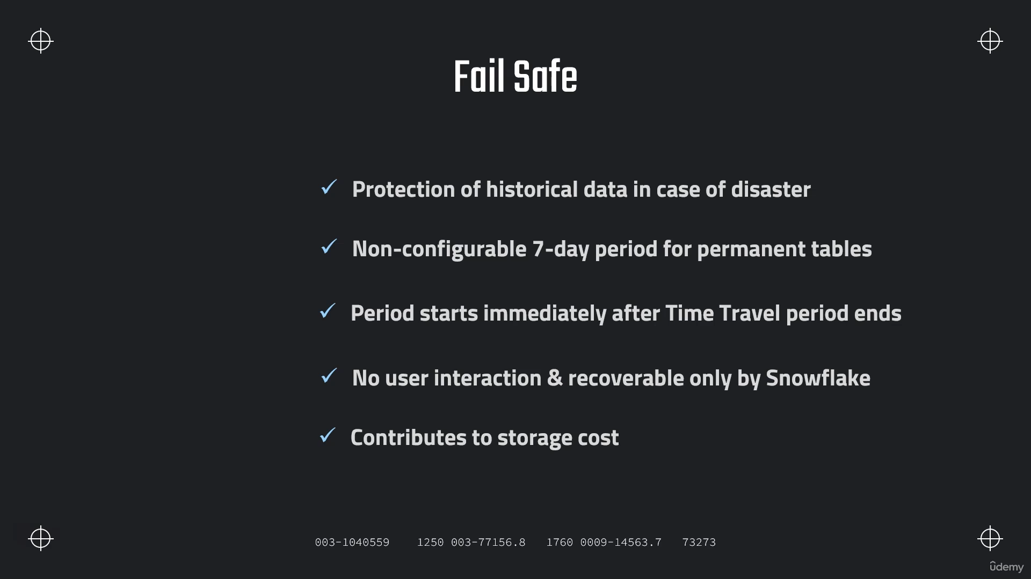

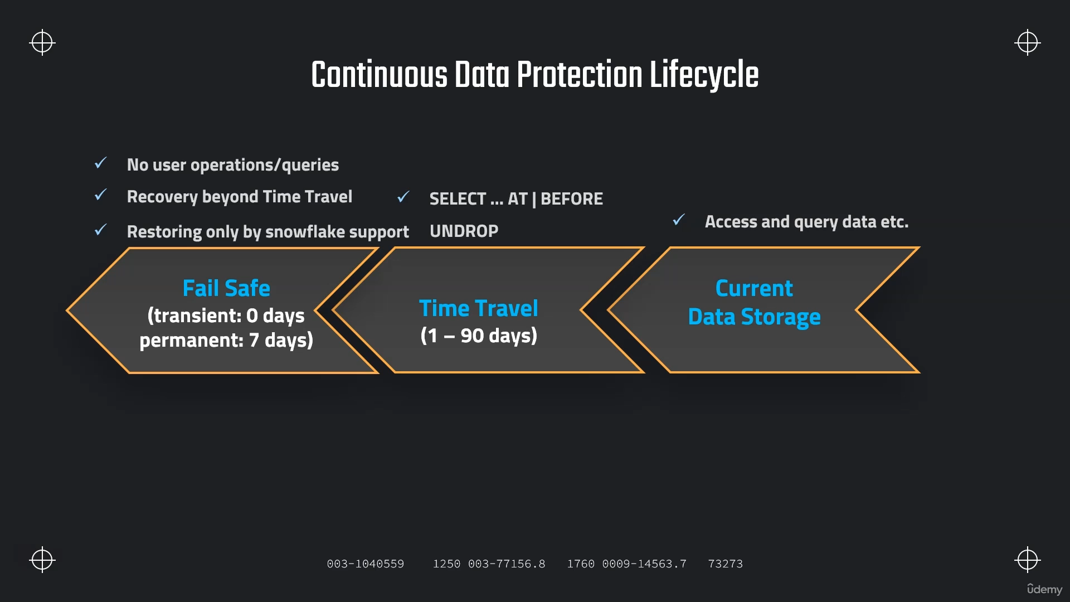

**// Storage usage on account level**

**SELECT * FROM SNOWFLAKE.ACCOUNT_USAGE.STORAGE_USAGE ORDER BY USAGE_DATE DESC;**

**// Storage usage on account level formatted**

**SELECT USAGE_DATE,**

**STORAGE_BYTES / (1024*1024*1024) AS STORAGE_GB,**

**STAGE_BYTES / (1024*1024*1024) AS STAGE_GB,**

**FAILSAFE_BYTES / (1024*1024*1024) AS FAILSAFE_GB**

**FROM SNOWFLAKE.ACCOUNT_USAGE.STORAGE_USAGE ORDER BY USAGE_DATE DESC;**

**// Storage usage on table level**

**SELECT * FROM SNOWFLAKE.ACCOUNT_USAGE.TABLE_STORAGE_METRICS;**

**// Storage usage on table level formatted**

**SELECT ID,**

**TABLE_NAME,**

**TABLE_SCHEMA,**

**ACTIVE_BYTES / (1024*1024*1024) AS STORAGE_USED_GB,**

**TIME_TRAVEL_BYTES / (1024*1024*1024) AS TIME_TRAVEL_STORAGE_USED_GB,**

**FAILSAFE_BYTES / (1024*1024*1024) AS FAILSAFE_STORAGE_USED_GB**

**FROM SNOWFLAKE.ACCOUNT_USAGE.TABLE_STORAGE_METRICS**

**ORDER BY FAILSAFE_STORAGE_USED_GB DESC;**

**Types of Tables :-**

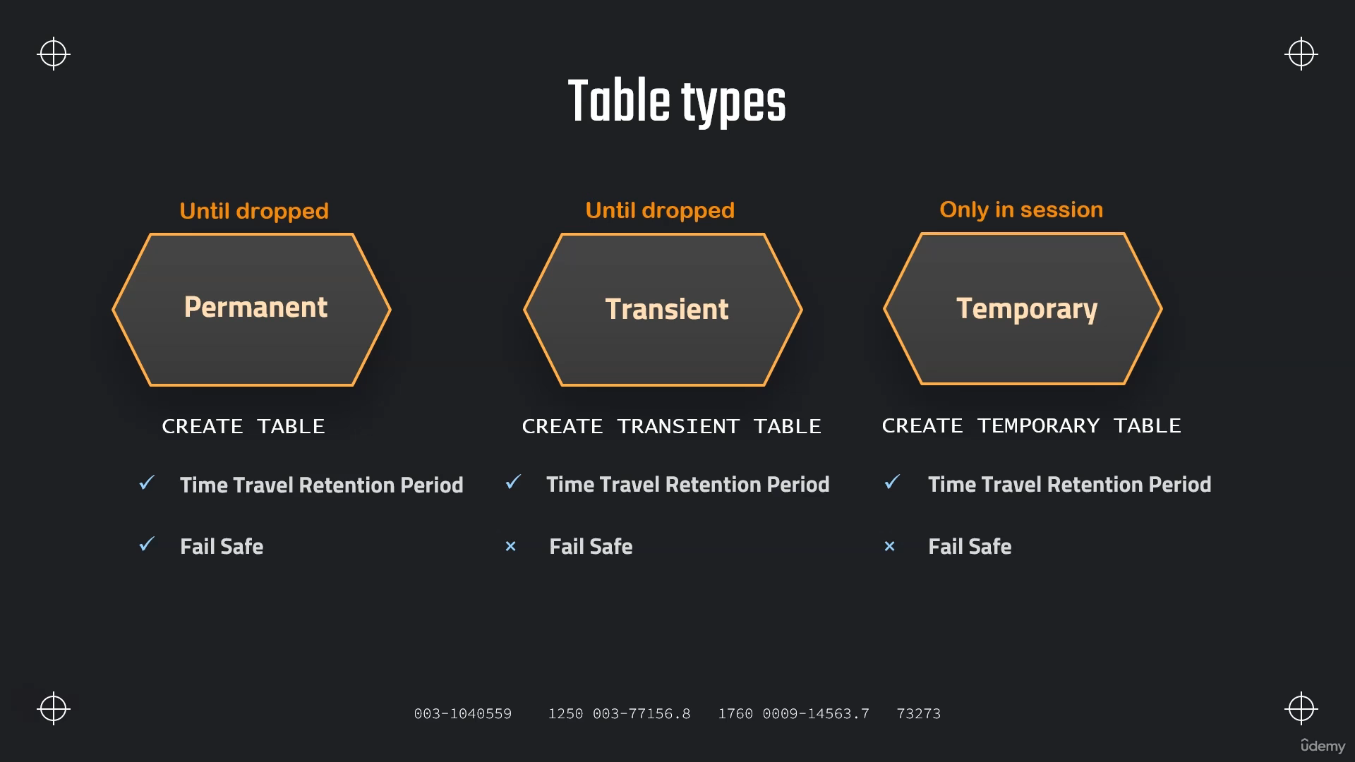

**Permanent Tables and Databases**

**CREATE OR REPLACE DATABASE PDB;**

**CREATE OR REPLACE TABLE PDB.public.customers (**

**id int,**

**first_name string,**

**last_name string,**

**email string,**

**gender string,**

**Job string,**

**Phone string);**

**CREATE OR REPLACE TABLE PDB.public.helper (**

**id int,**

**first_name string,**

**last_name string,**

**email string,**

**gender string,**

**Job string,**

**Phone string);**

**// Stage and file format**

**CREATE OR REPLACE FILE FORMAT MANAGE_DB.file_formats.csv_file**

**type = csv**

**field_delimiter = ','**

**skip_header = 1**

**CREATE OR REPLACE STAGE MANAGE_DB.external_stages.time_travel_stage**

**URL = 's3://data-snowflake-fundamentals/time-travel/'**

**file_format = MANAGE_DB.file_formats.csv_file;**

**LIST @MANAGE_DB.external_stages.time_travel_stage;**

**// Copy data and insert in table**

**COPY INTO PDB.public.helper**

**FROM @MANAGE_DB.external_stages.time_travel_stage**

**files = ('customers.csv');**

**SELECT * FROM PDB.public.helper;**

**INSERT INTO PDB.public.customers**

**SELECT**

**t1.ID**

**,t1.FIRST_NAME**

**,t1.LAST_NAME**

**,t1.EMAIL**

**,t1.GENDER**

**,t1.JOB**

**,t1.PHONE**

**FROM PDB.public.helper t1**

**CROSS JOIN (SELECT * FROM PDB.public.helper) t2**

**CROSS JOIN (SELECT TOP 100 * FROM PDB.public.helper) t3;**

**// Show table and validate**

**SHOW TABLES;**

**// Permanent tables**

**USE OUR_FIRST_DB**

**CREATE OR REPLACE TABLE customers (**

**id int,**

**first_name string,**

**last_name string,**

**email string,**

**gender string,**

**Job string,**

**Phone string);**

**CREATE OR REPLACE DATABASE PDB;**

**SHOW DATABASES;**

**SHOW TABLES;**

**// View table metrics (takes a bit to appear)**

**SELECT * FROM SNOWFLAKE.ACCOUNT_USAGE.TABLE_STORAGE_METRICS**

**SELECT ID,**

**TABLE_NAME,**

**TABLE_SCHEMA,**

**TABLE_CATALOG,**

**ACTIVE_BYTES / (1024*1024*1024) AS ACTIVE_STORAGE_USED_GB,**

**TIME_TRAVEL_BYTES / (1024*1024*1024) AS TIME_TRAVEL_STORAGE_USED_GB,**

**FAILSAFE_BYTES / (1024*1024*1024) AS FAILSAFE_STORAGE_USED_GB,**

**IS_TRANSIENT,**

**DELETED,**

**TABLE_CREATED,**

**TABLE_DROPPED,**

**TABLE_ENTERED_FAILSAFE**

**FROM SNOWFLAKE.ACCOUNT_USAGE.TABLE_STORAGE_METRICS**

**--WHERE TABLE_CATALOG ='PDB'**

**WHERE TABLE_DROPPED is not null**

**ORDER BY FAILSAFE_BYTES DESC;**

**Transient Tables :-**

**CREATE OR REPLACE DATABASE TDB;**

**CREATE OR REPLACE TRANSIENT TABLE TDB.public.customers_transient (**

**id int,**

**first_name string,**

**last_name string,**

**email string,**

**gender string,**

**Job string,**

**Phone string);**

**INSERT INTO TDB.public.customers_transient**

**SELECT t1.* FROM OUR_FIRST_DB.public.customers t1**

**CROSS JOIN (SELECT * FROM OUR_FIRST_DB.public.customers) t2**

**SHOW TABLES;**

**// Query storage**

**SELECT * FROM SNOWFLAKE.ACCOUNT_USAGE.TABLE_STORAGE_METRICS**

**SELECT ID,**

**TABLE_NAME,**

**TABLE_SCHEMA,**

**TABLE_CATALOG,**

**ACTIVE_BYTES,**

**TIME_TRAVEL_BYTES / (1024*1024*1024) AS TIME_TRAVEL_STORAGE_USED_GB,**

**FAILSAFE_BYTES / (1024*1024*1024) AS FAILSAFE_STORAGE_USED_GB,**

**IS_TRANSIENT,**

**DELETED,**

**TABLE_CREATED,**

**TABLE_DROPPED,**

**TABLE_ENTERED_FAILSAFE**

**FROM SNOWFLAKE.ACCOUNT_USAGE.TABLE_STORAGE_METRICS**

**WHERE TABLE_CATALOG ='TDB'**

**ORDER BY TABLE_CREATED DESC;**

**// Set retention time to 0**

**ALTER TABLE TDB.public.customers_transient**

**SET DATA_RETENTION_TIME_IN_DAYS = 0**

**DROP TABLE TDB.public.customers_transient;**

**UNDROP TABLE TDB.public.customers_transient;**

**SHOW TABLES;**

**// Creating transient schema and then table**

**CREATE OR REPLACE TRANSIENT SCHEMA TRANSIENT_SCHEMA;**

**SHOW SCHEMAS;**

**CREATE OR REPLACE TABLE TDB.TRANSIENT_SCHEMA.new_table (**

**id int,**

**first_name string,**

**last_name string,**

**email string,**

**gender string,**

**Job string,**

**Phone string);**

**ALTER TABLE TDB.TRANSIENT_SCHEMA.new_table**

**SET DATA_RETENTION_TIME_IN_DAYS = 2**

**SHOW TABLES;**

**Zero Copy Cloning :-**

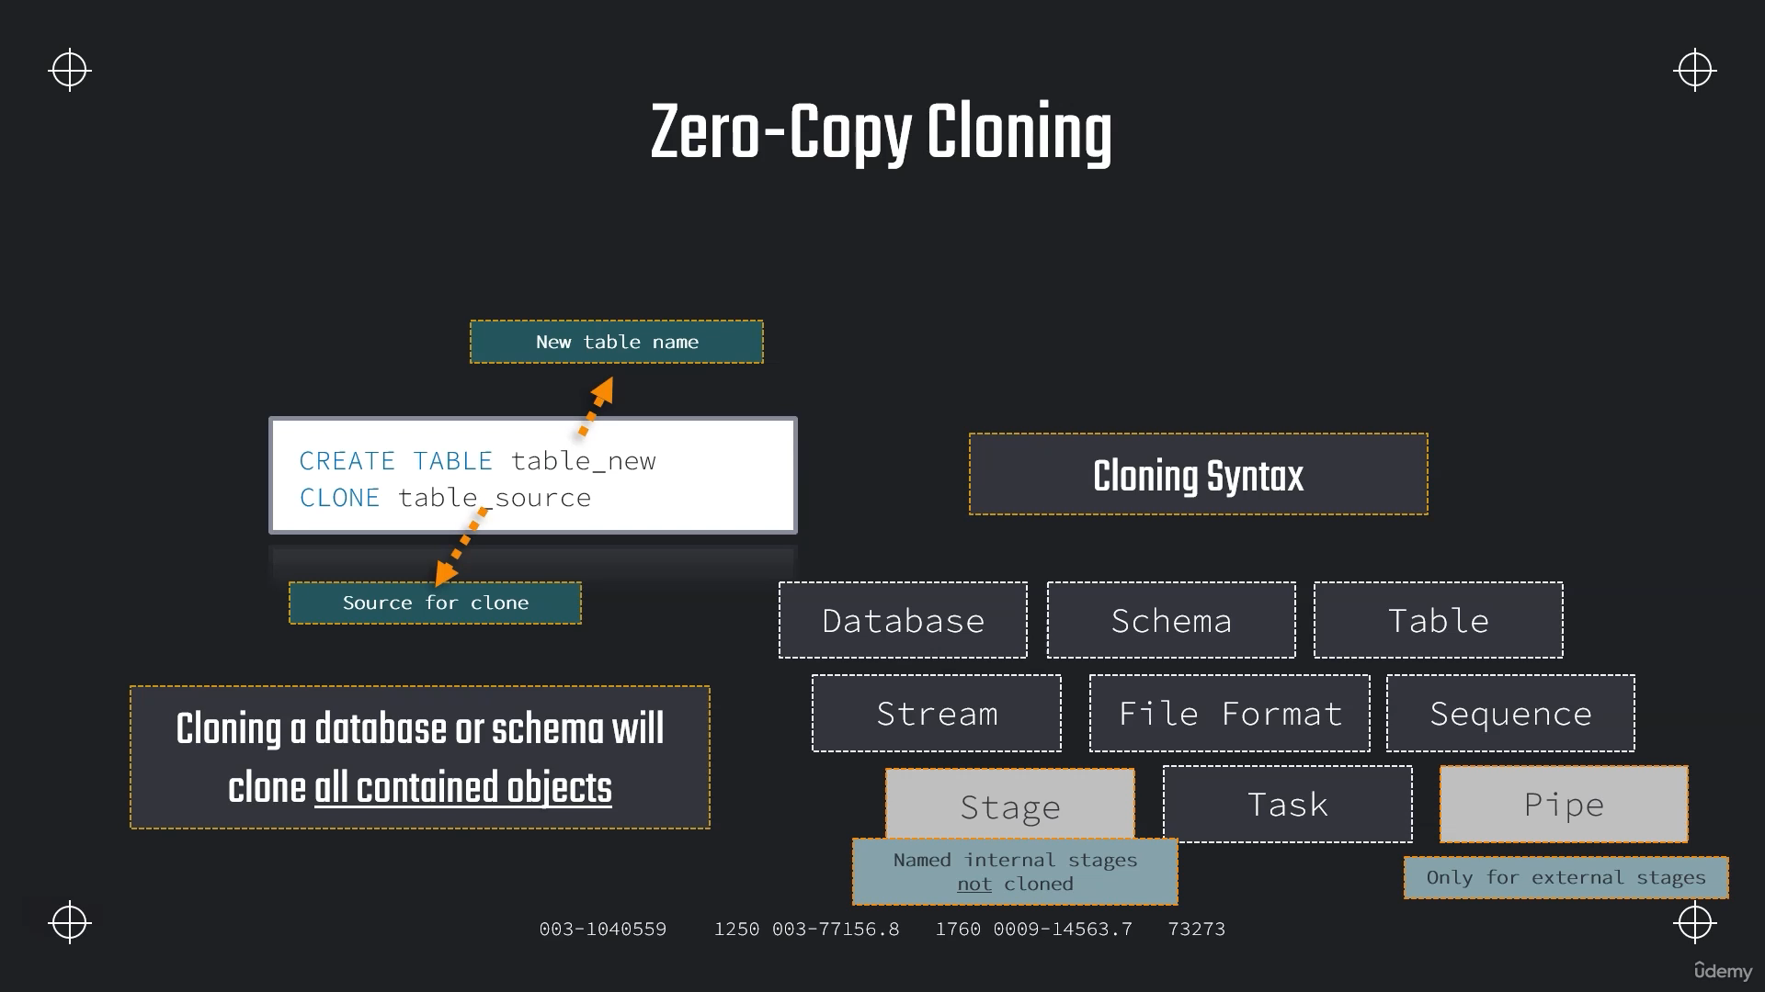

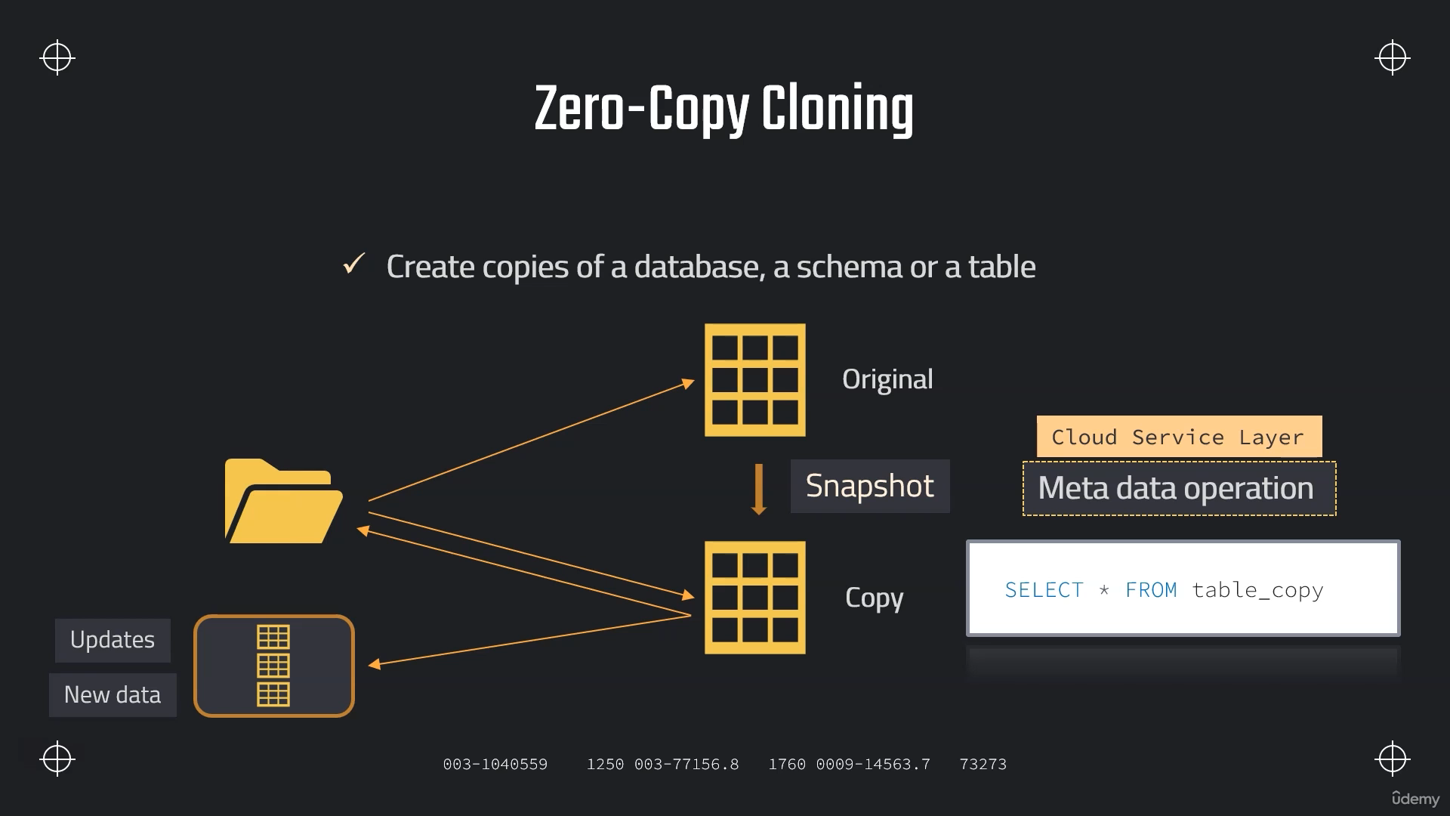

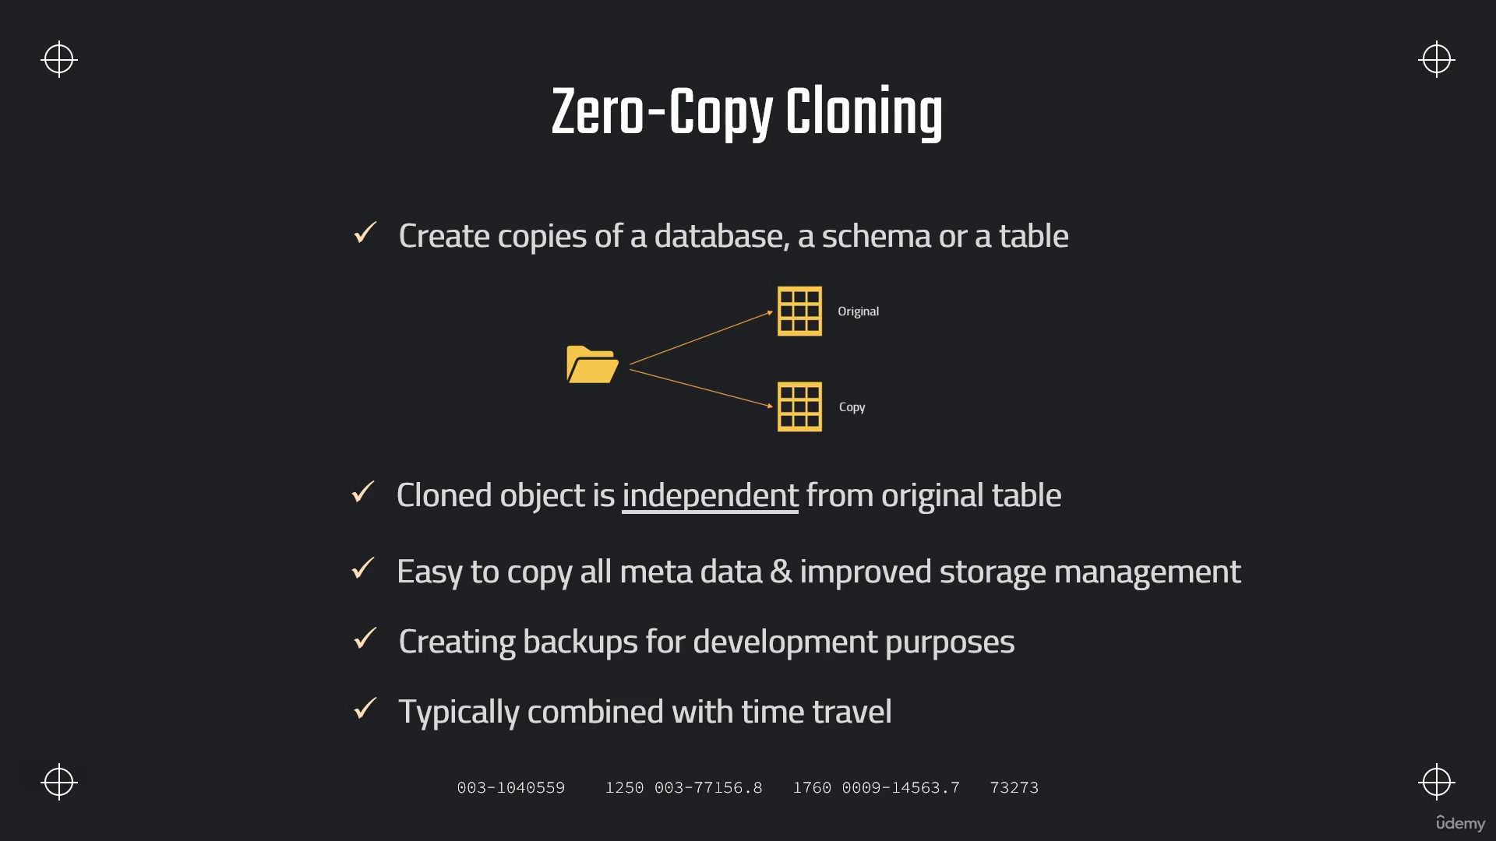

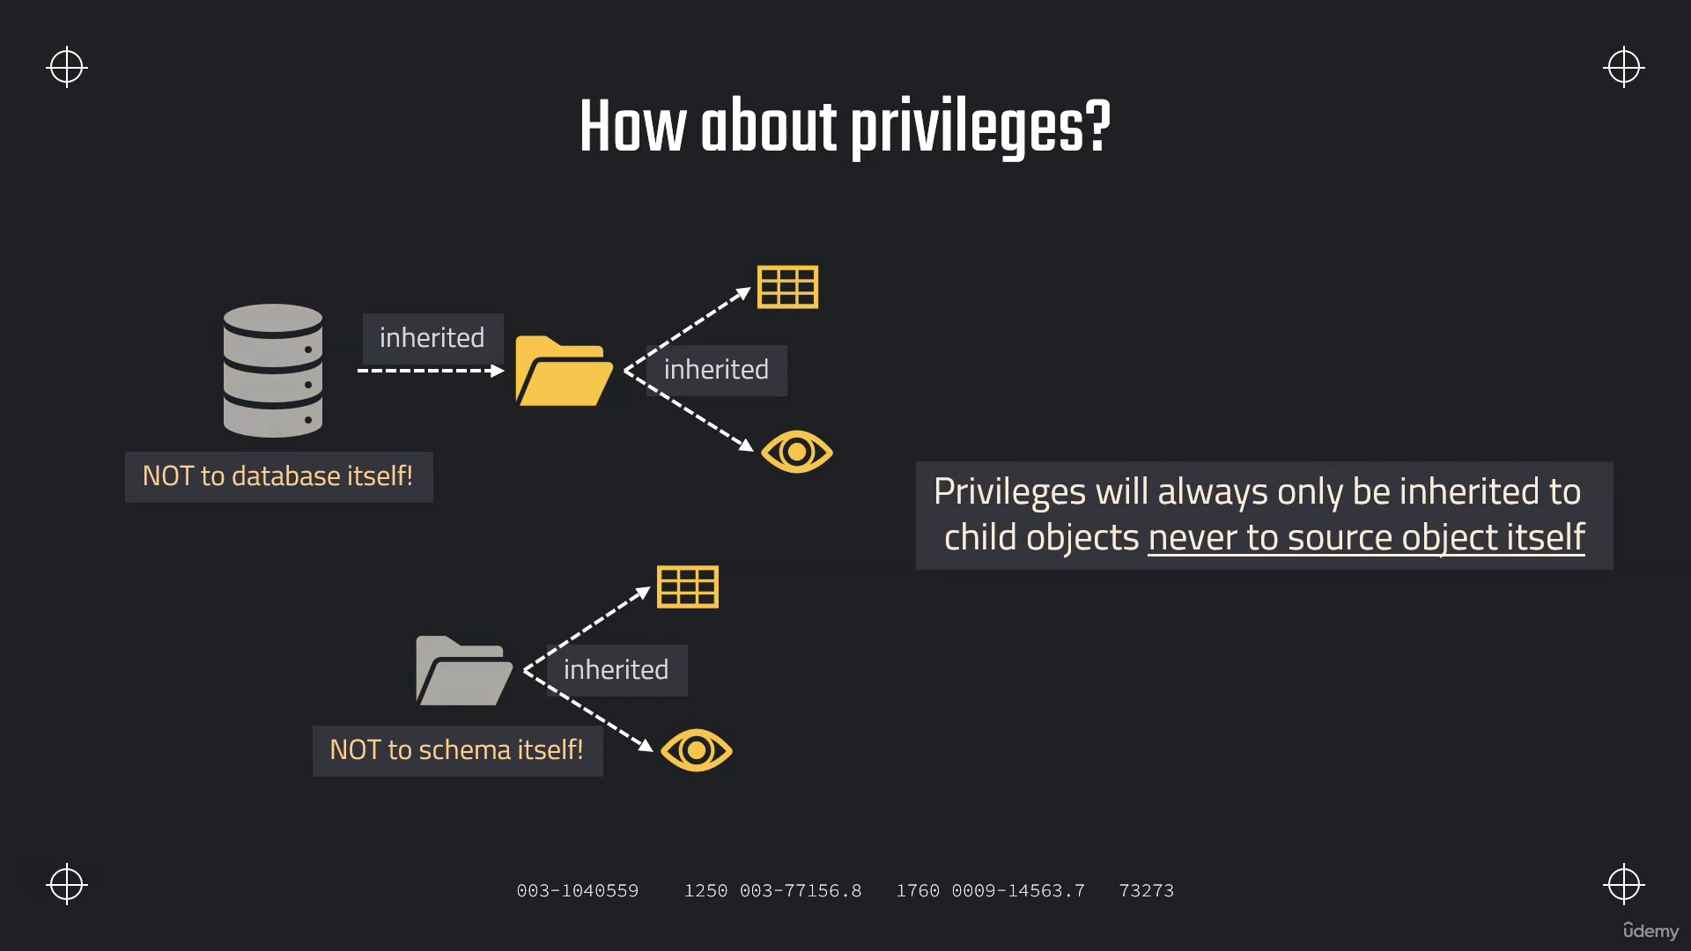

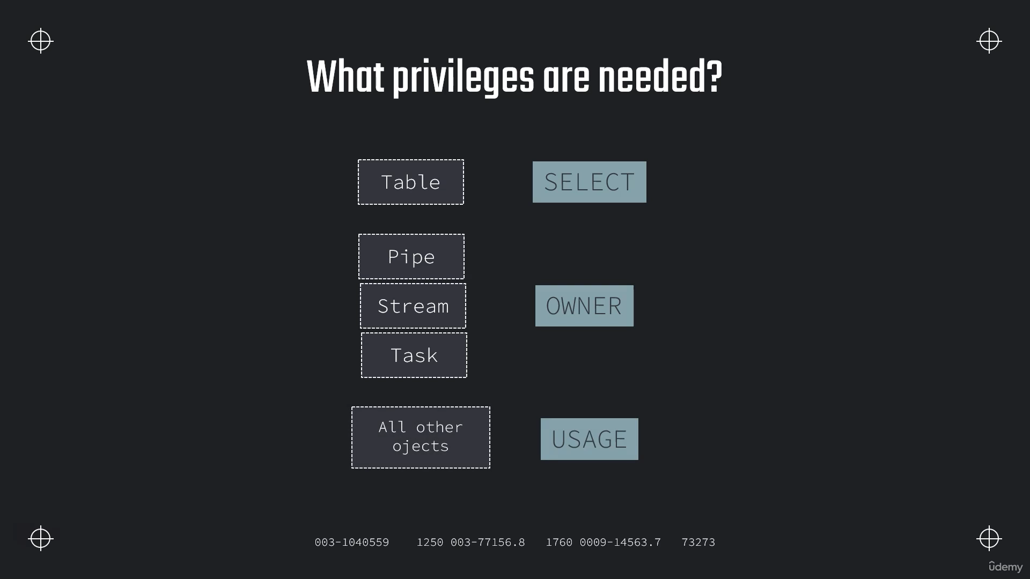

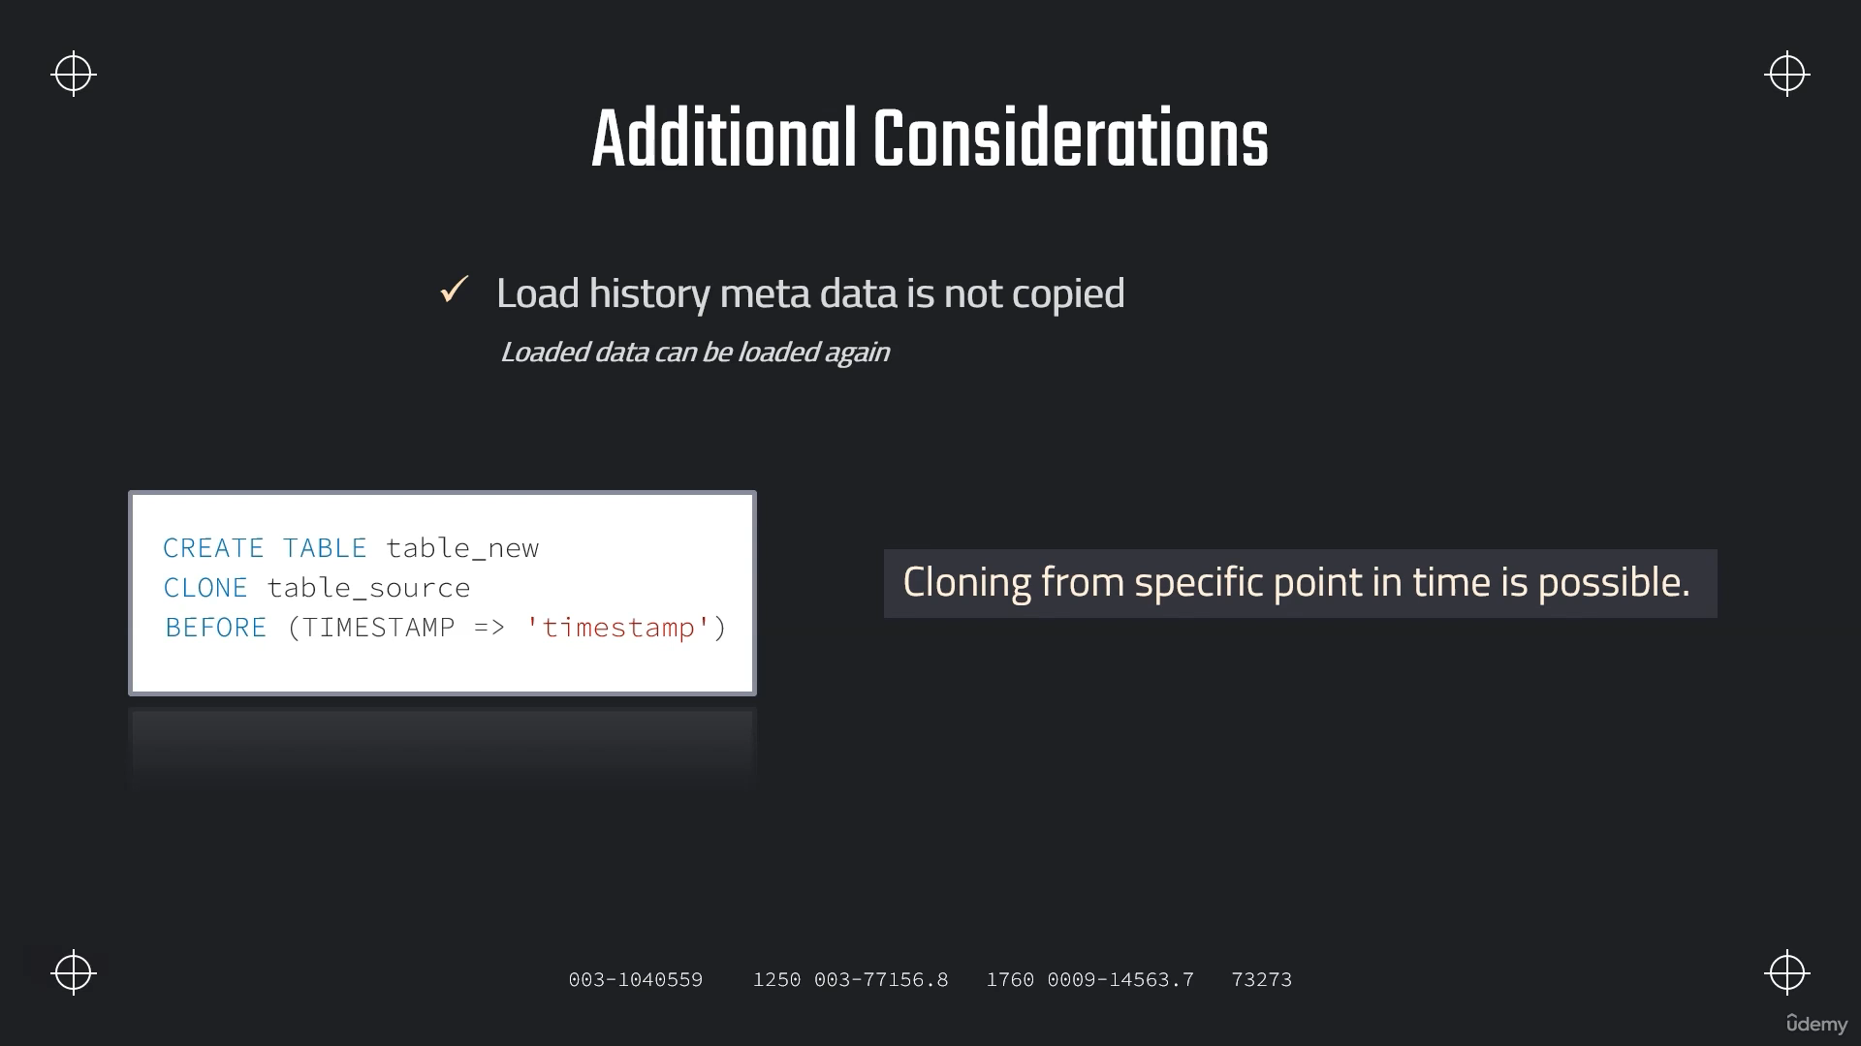

**Cloning Tables**

**// Cloning**

**SELECT * FROM OUR_FIRST_DB.PUBLIC.CUSTOMERS;**

**CREATE TABLE OUR_FIRST_DB.PUBLIC.CUSTOMERS_CLONE**

**CLONE OUR_FIRST_DB.PUBLIC.CUSTOMERS;**

**// Validate the data**

**SELECT * FROM OUR_FIRST_DB.PUBLIC.CUSTOMERS_CLONE;**

**// Update cloned table**

**UPDATE OUR_FIRST_DB.public.CUSTOMERS_CLONE**

**SET LAST_NAME = NULL;**

**SELECT * FROM OUR_FIRST_DB.PUBLIC.CUSTOMERS ;**

**SELECT * FROM OUR_FIRST_DB.PUBLIC.CUSTOMERS_CLONE;**

**// Cloning a temporary table is not possible**

**CREATE OR REPLACE TEMPORARY TABLE OUR_FIRST_DB.PUBLIC.TEMP_TABLE(**

**id int);**

**CREATE TEMPORARY TABLE OUR_FIRST_DB.PUBLIC.TABLE_COPY**

**CLONE OUR_FIRST_DB.PUBLIC.TEMP_TABLE;**

**SELECT * FROM OUR_FIRST_DB.PUBLIC.TABLE_COPY;**

**Cloning Schemas and Databases**

**// Cloning Schema**

**CREATE TRANSIENT SCHEMA OUR_FIRST_DB.COPIED_SCHEMA**

**CLONE OUR_FIRST_DB.PUBLIC;**

**SELECT * FROM COPIED_SCHEMA.CUSTOMERS;**

**CREATE TRANSIENT SCHEMA OUR_FIRST_DB.EXTERNAL_STAGES_COPIED**

**CLONE MANAGE_DB.EXTERNAL_STAGES;**

**// Cloning Database**

**CREATE TRANSIENT DATABASE OUR_FIRST_DB_COPY**

**CLONE OUR_FIRST_DB;**

**DROP DATABASE OUR_FIRST_DB_COPY;**

**DROP SCHEMA OUR_FIRST_DB.EXTERNAL_STAGES_COPIED;**

**DROP SCHEMA OUR_FIRST_DB.COPIED_SCHEMA;**

**Cloning with Time Travel**

**// Cloning using time travel**

**// Setting up table**

**CREATE OR REPLACE TABLE OUR_FIRST_DB.public.time_travel (**

**id int,**

**first_name string,**

**last_name string,**

**email string,**

**gender string,**

**Job string,**

**Phone string);**

**CREATE OR REPLACE FILE FORMAT MANAGE_DB.file_formats.csv_file**

**type = csv**

**field_delimiter = ','**

**skip_header = 1;**

**CREATE OR REPLACE STAGE MANAGE_DB.external_stages.time_travel_stage**

**URL = 's3://data-snowflake-fundamentals/time-travel/'**

**file_format = MANAGE_DB.file_formats.csv_file;**

**LIST @MANAGE_DB.external_stages.time_travel_stage;**

**COPY INTO OUR_FIRST_DB.public.time_travel**

**from @MANAGE_DB.external_stages.time_travel_stage**

**files = ('customers.csv');**

**SELECT * FROM OUR_FIRST_DB.public.time_travel;**

**// Update data**

**UPDATE OUR_FIRST_DB.public.time_travel**

**SET FIRST_NAME = 'Frank' ;**

**// Using time travel**

**SELECT * FROM OUR_FIRST_DB.public.time_travel at (OFFSET => -60*1);**

**// Using time travel**

**CREATE OR REPLACE TABLE OUR_FIRST_DB.PUBLIC.time_travel_clone**

**CLONE OUR_FIRST_DB.public.time_travel at (OFFSET => -60*1);**

**SELECT * FROM OUR_FIRST_DB.PUBLIC.time_travel_clone;**

**// Update data again**

**UPDATE OUR_FIRST_DB.public.time_travel_clone**

**SET JOB = 'Snowflake Analyst' ;**

**// Using time travel: Method 2 - before Query**

**SELECT * FROM OUR_FIRST_DB.public.time_travel_clone before (statement => '01b987a0-030b-e007-000a-7df70004006e');**

**CREATE OR REPLACE TABLE OUR_FIRST_DB.PUBLIC.time_travel_clone_of_clone**

**CLONE OUR_FIRST_DB.public.time_travel_clone before (statement => '01b987a0-030b-e007-000a-7df70004006e');**

**SELECT * FROM OUR_FIRST_DB.public.time_travel_clone_of_clone ;**

**Swapping Tables**

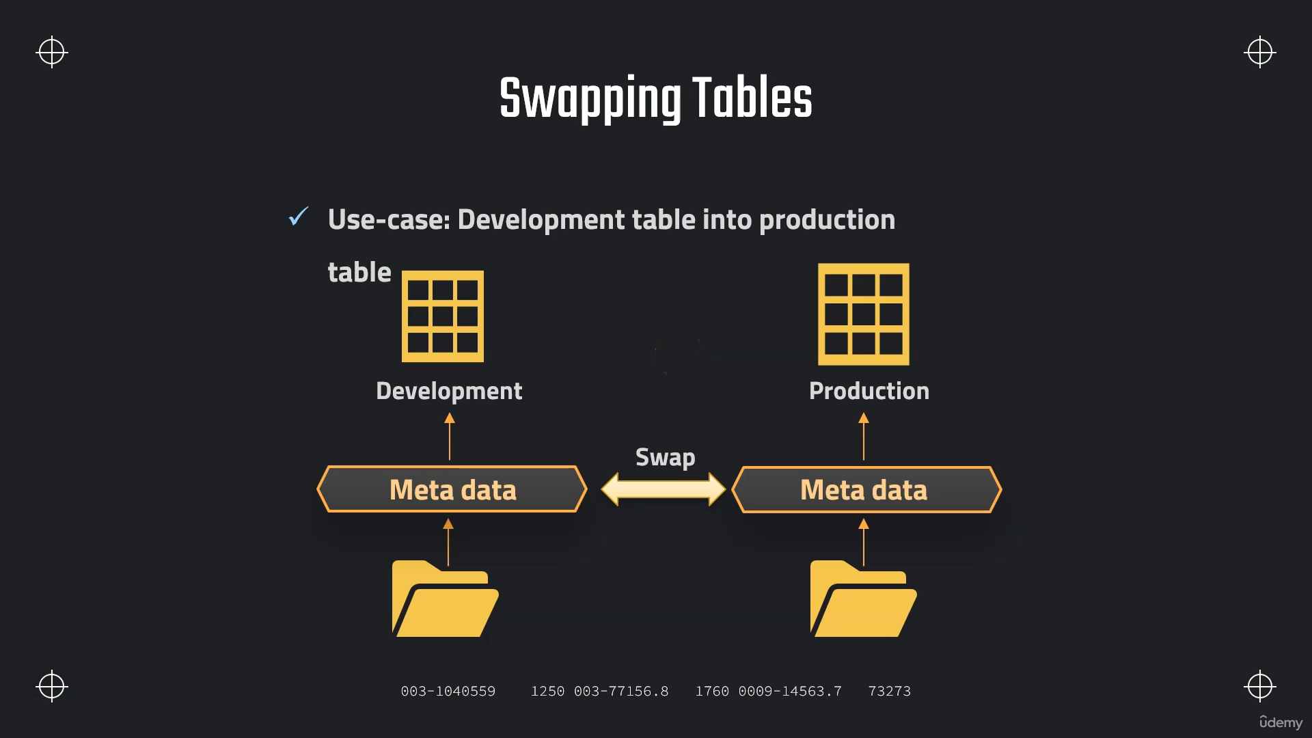

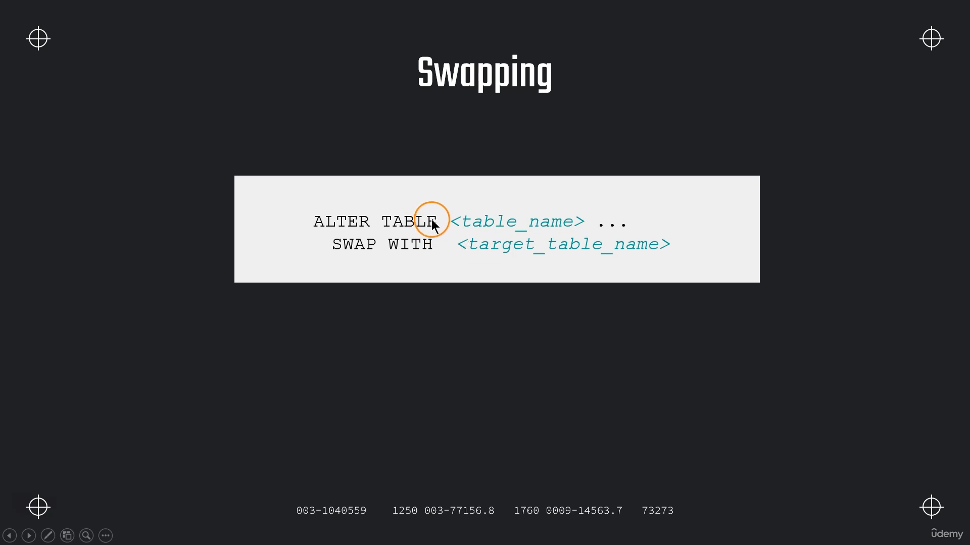

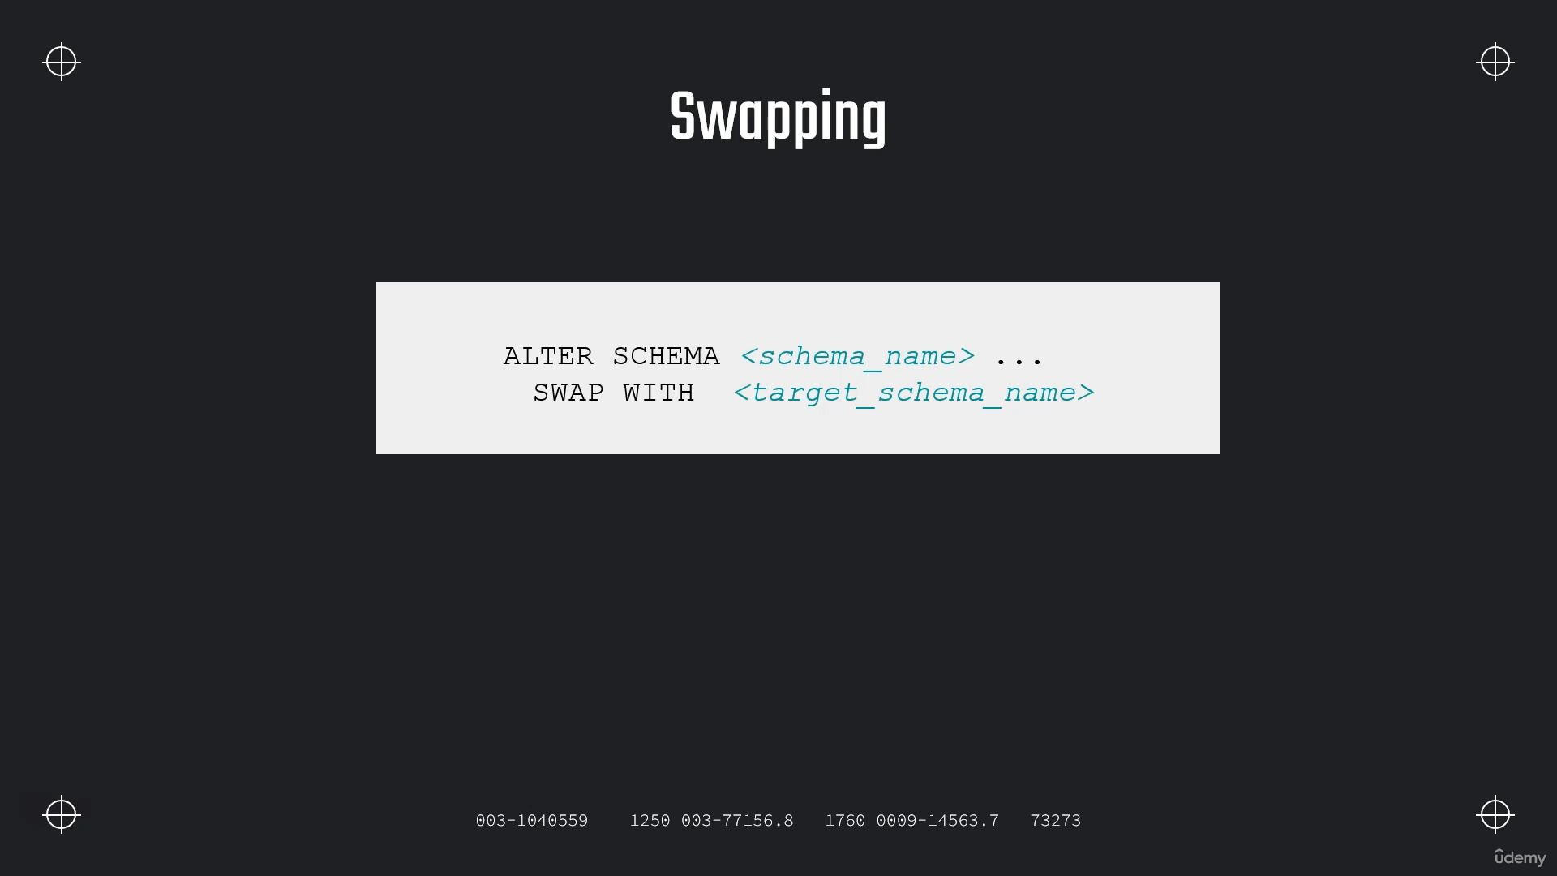

**//// Swapping tables**

**// Setting up dev table**

**CREATE TRANSIENT SCHEMA OUR_FIRST_DB.COPIED_SCHEMA**

**CLONE OUR_FIRST_DB.PUBLIC;**

**SELECT * FROM OUR_FIRST_DB.COPIED_SCHEMA.CUSTOMERS**

**SELECT * FROM OUR_FIRST_DB.PUBLIC.CUSTOMERS**

**// Modifying "Dev Table"**

**DELETE FROM OUR_FIRST_DB.COPIED_SCHEMA.CUSTOMERS WHERE ID < 500**

**SELECT * FROM OUR_FIRST_DB.COPIED_SCHEMA.CUSTOMERS**

**// Swapping Tables**

**ALTER TABLE OUR_FIRST_DB.COPIED_SCHEMA.CUSTOMERS**

**SWAP WITH OUR_FIRST_DB.PUBLIC.CUSTOMERS**

**// Verifying results**

**SELECT * FROM OUR_FIRST_DB.COPIED_SCHEMA.CUSTOMERS;**

**SELECT * FROM OUR_FIRST_DB.PUBLIC.CUSTOMERS;**

**Assignment :**

**USE ROLE ACCOUNTDMIN;**

**USE DATABASE DEMO_DB;**

**USE WAREHOUSE COMPUTE_WH;**

**CREATE OR REPLACE TABLE DEMO_DB.PUBLIC.SUPPLIER**

**AS**

**SELECT * FROM "SNOWFLAKE_SAMPLE_DATA"."TPCH_SF1"."SUPPLIER";**

**CREATE OR REPLACE TABLE DEMO_DB.PUBLIC.SUPPLIER_clone**

**CLONE DEMO_DB.PUBLIC.SUPPLIER;**

**select * from DEMO_DB.PUBLIC.SUPPLIER;**

**select * from DEMO_DB.PUBLIC.SUPPLIER_CLONE;**

**UPDATE SUPPLIER_CLONE**

**SET S_PHONE='###';**

**01b987af-030b-e007-000a-7df700040102;**

**CREATE OR REPLACE TABLE DEMO_DB.PUBLIC.SUPPLIER_clone_upd**

**CLONE DEMO_DB.PUBLIC.SUPPLIER_clone before (statement => '01b987af-030b-e007-000a-7df700040102');**

**select * from DEMO_DB.PUBLIC.SUPPLIER;**

**select * from DEMO_DB.PUBLIC.SUPPLIER_CLONE;**

**select * from DEMO_DB.PUBLIC.SUPPLIER_CLONE_upd;**

**delete from DEMO_DB.PUBLIC.SUPPLIER_CLONE;**

**Data Sharing :**

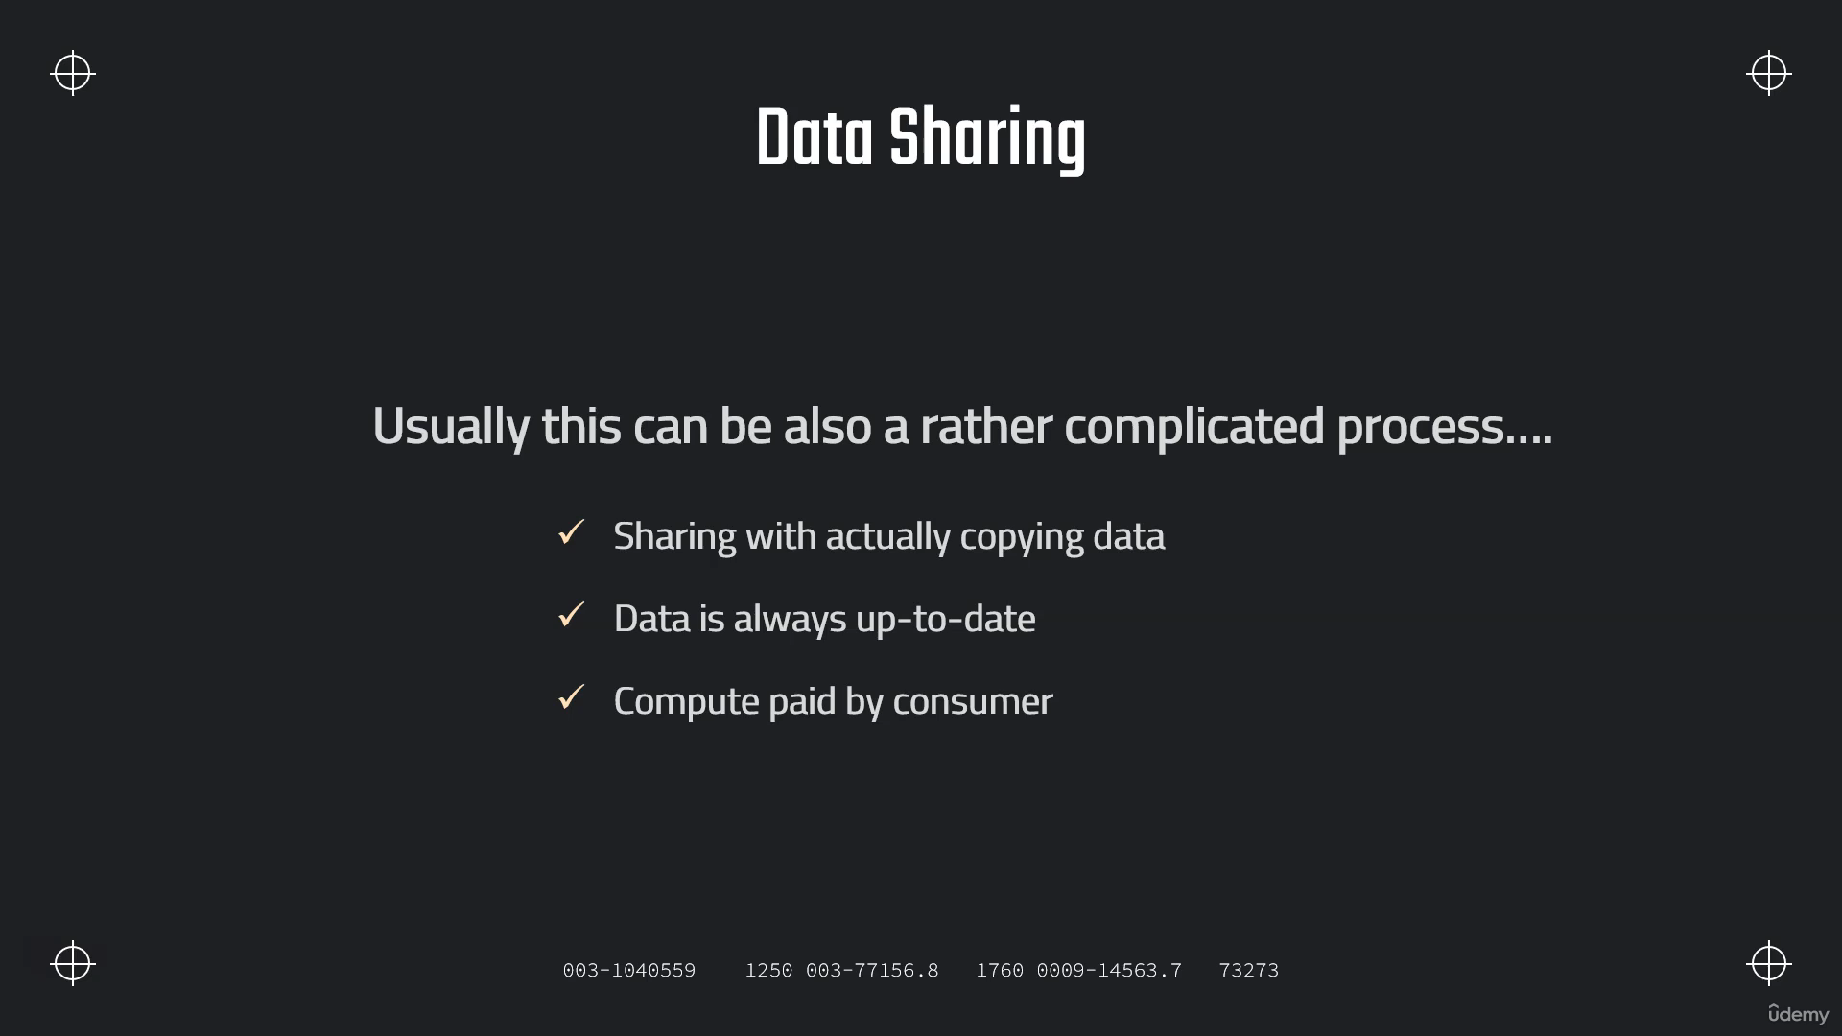

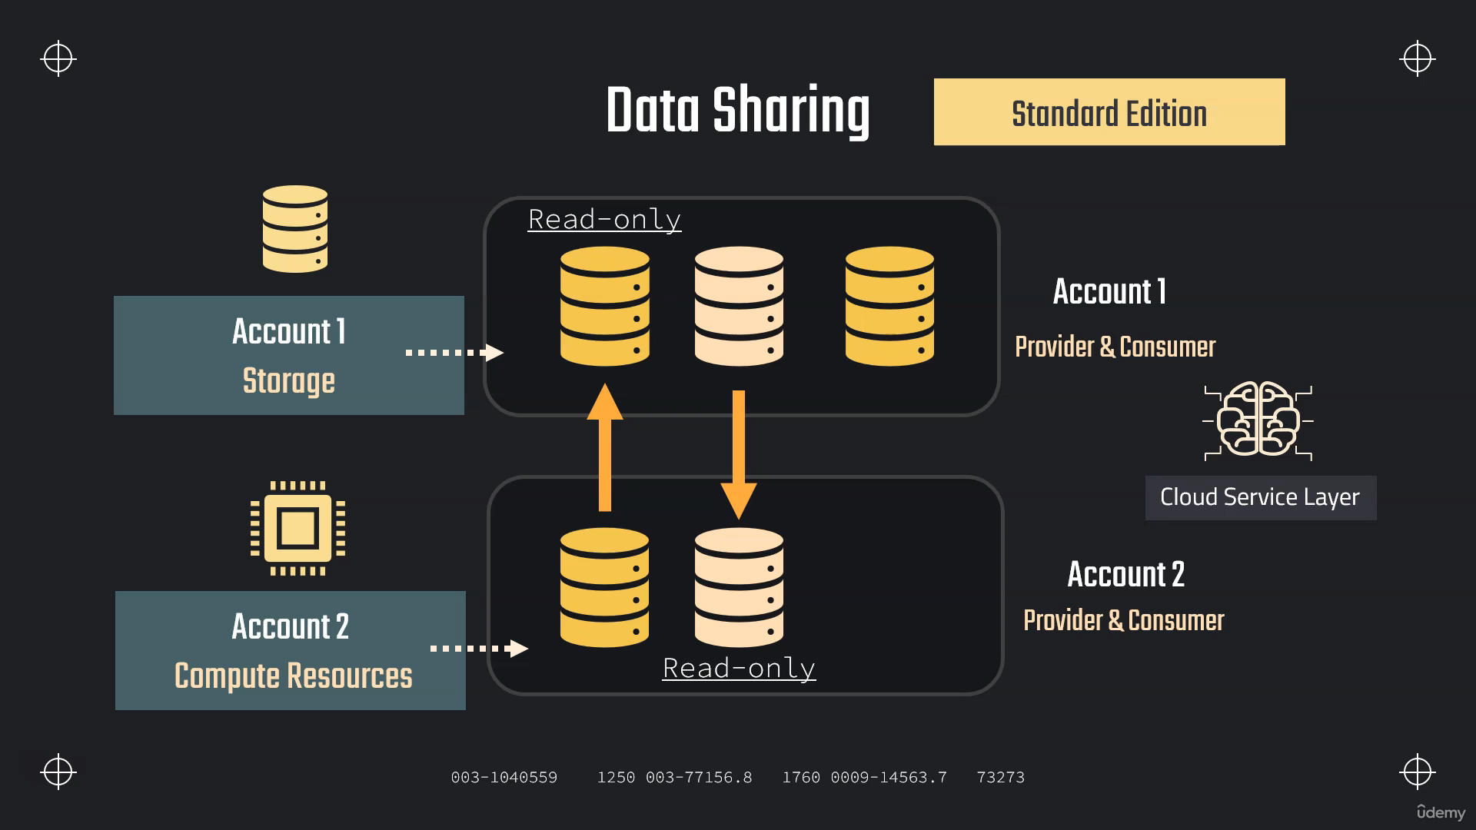

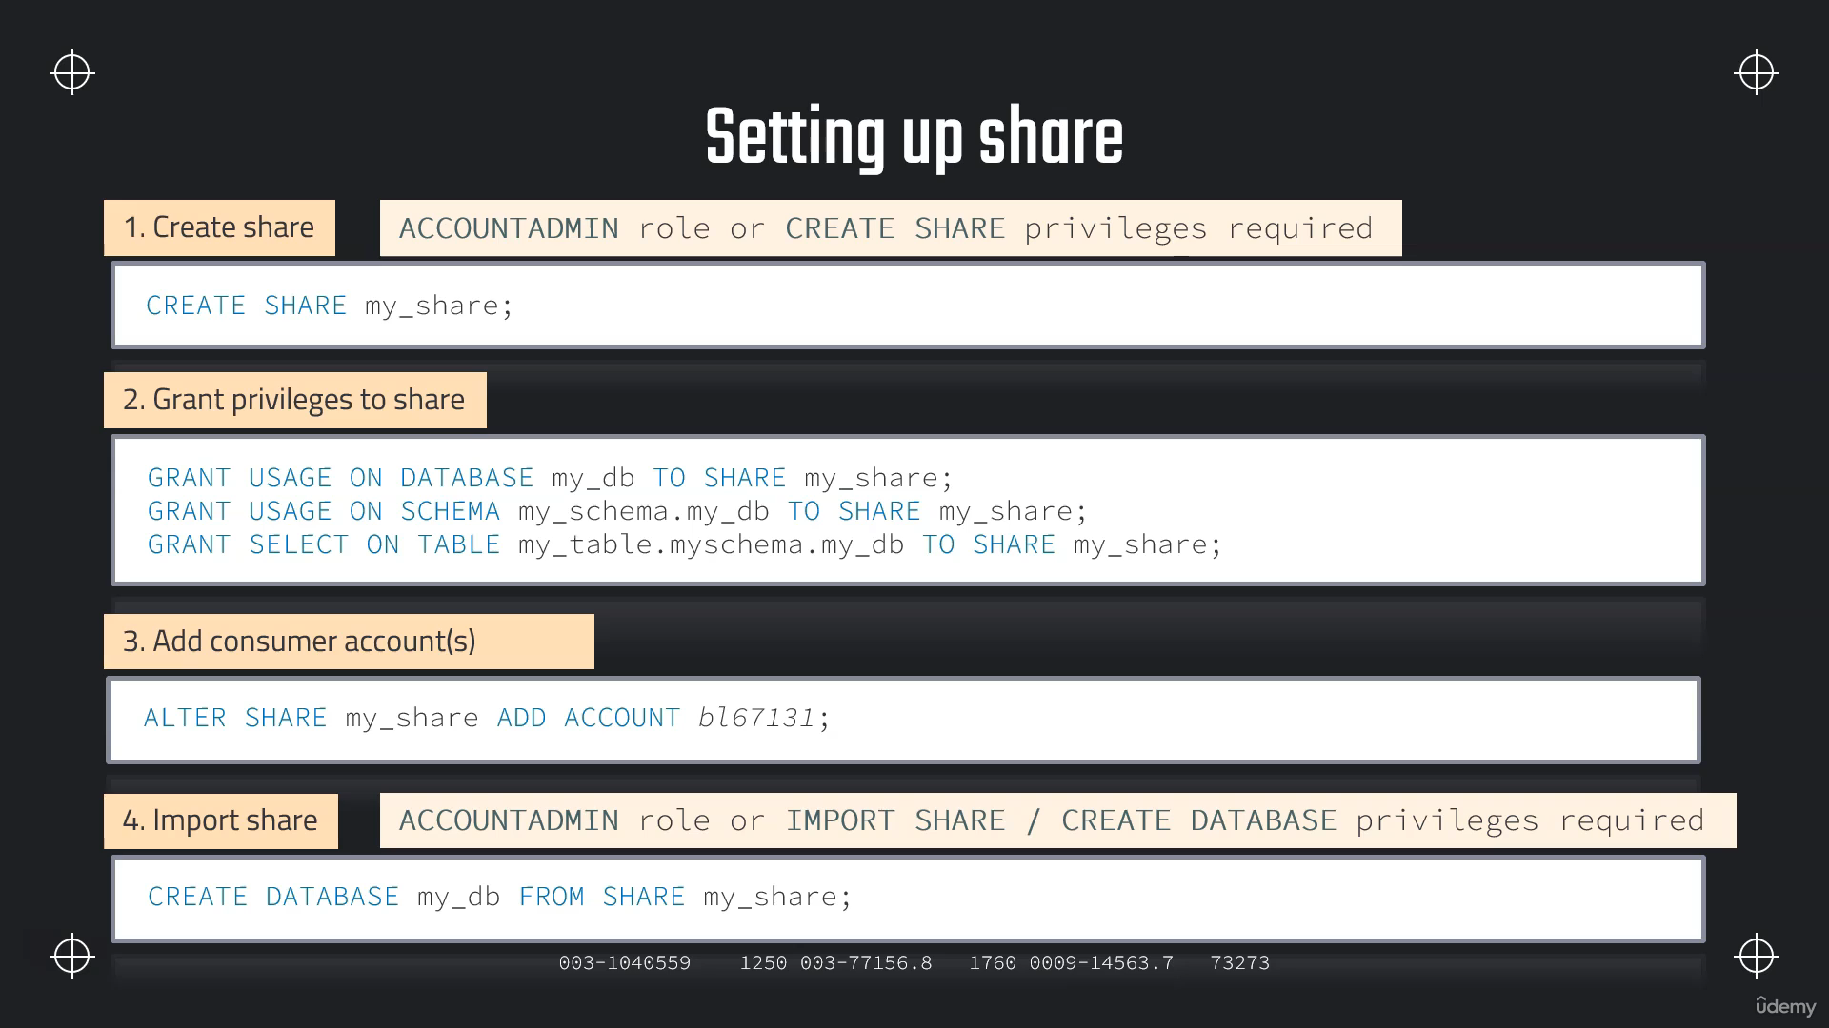

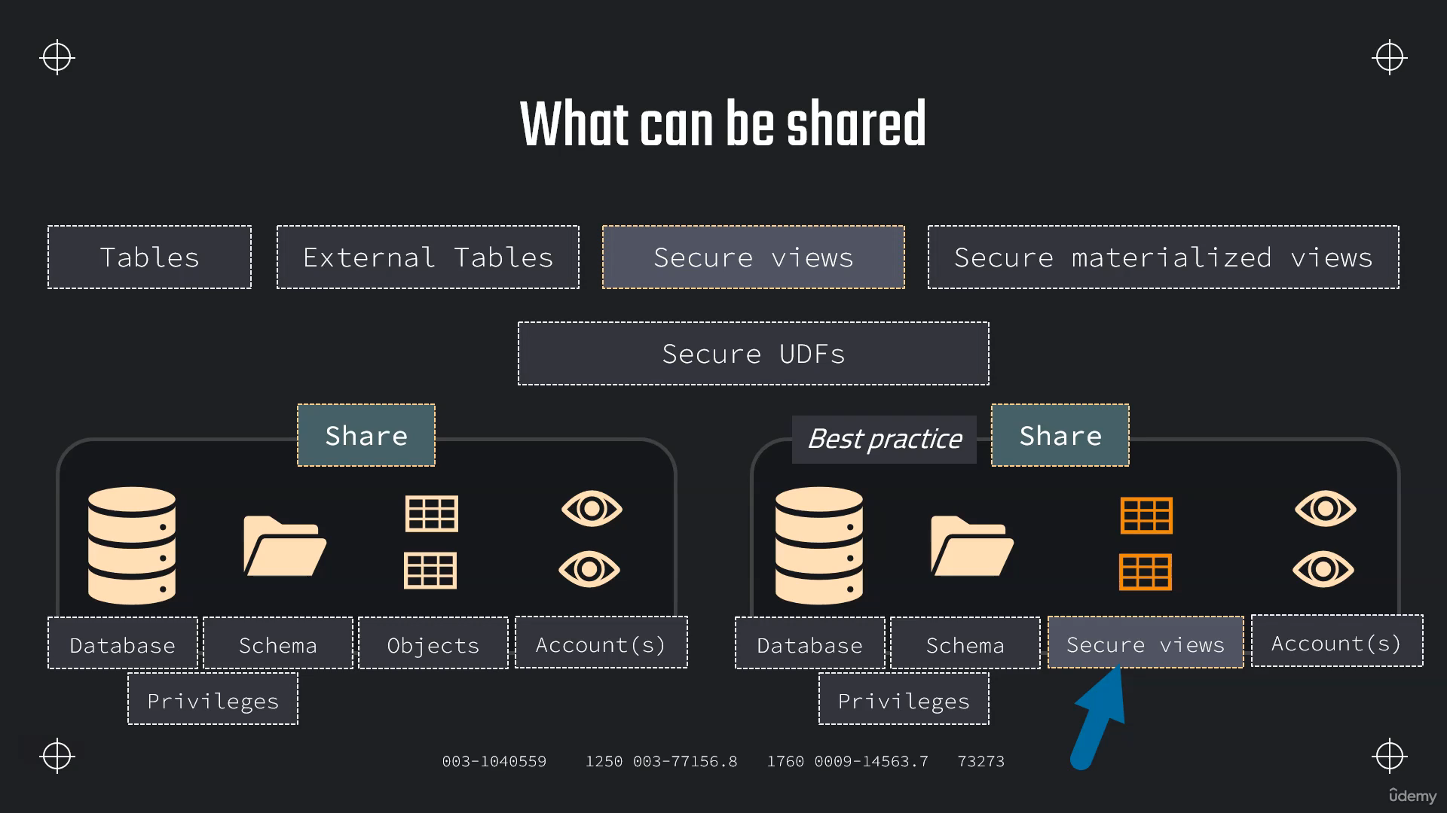

**Using Data Sharing**

**CREATE OR REPLACE DATABASE DATA_S;**

**CREATE OR REPLACE STAGE aws_stage**

**url='s3://bucketsnowflakes3';**

**// List files in stage**

**LIST @aws_stage;**

**// Create table**

**CREATE OR REPLACE TABLE ORDERS (**

**ORDER_ID VARCHAR(30)**

**,AMOUNT NUMBER(38,0)**

**,PROFIT NUMBER(38,0)**

**,QUANTITY NUMBER(38,0)**

**,CATEGORY VARCHAR(30)**

**,SUBCATEGORY VARCHAR(30));**

**// Load data using copy command**

**COPY INTO ORDERS**

**FROM @MANAGE_DB.external_stages.aws_stage**

**file_format= (type = csv field_delimiter=',' skip_header=1)**

**pattern='.*OrderDetails.*';**

**SELECT * FROM ORDERS;**

**// Create a share object**

**CREATE OR REPLACE SHARE ORDERS_SHARE;**

**---- Setup Grants ----**

**// Grant usage on database**

**GRANT USAGE ON DATABASE DATA_S TO SHARE ORDERS_SHARE;**

**// Grant usage on schema**

**GRANT USAGE ON SCHEMA DATA_S.PUBLIC TO SHARE ORDERS_SHARE;**

**// Grant SELECT on table**

**GRANT SELECT ON TABLE DATA_S.PUBLIC.ORDERS TO SHARE ORDERS_SHARE;**

**// Validate Grants**

**SHOW GRANTS TO SHARE ORDERS_SHARE;**

**---- Add Consumer Account ----**

**ALTER SHARE ORDERS_SHARE ADD ACCOUNT=OEB58837;**

**Create Share using Interface**

**Data Products->Private Sharing->Share->Create Direct Share**

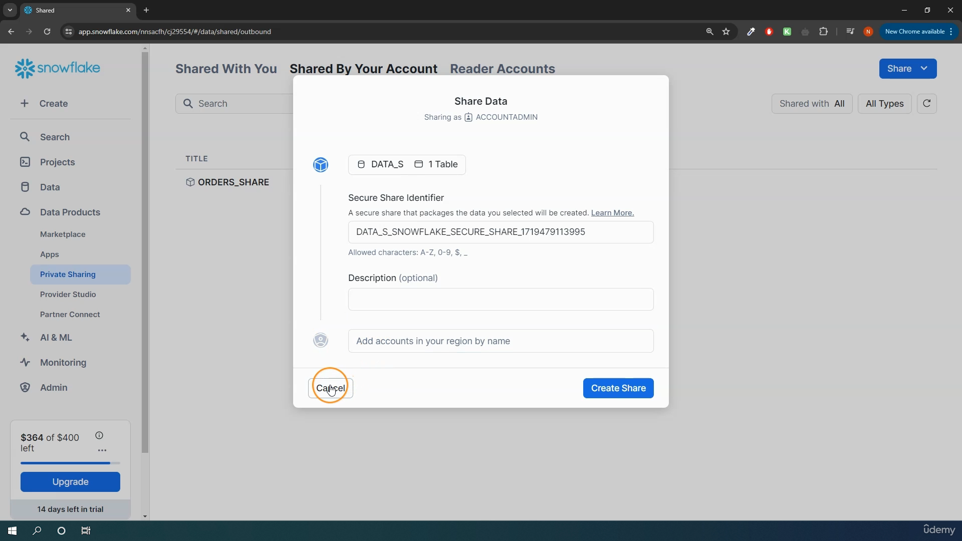

**Data sharing with Non-Snowflake account**

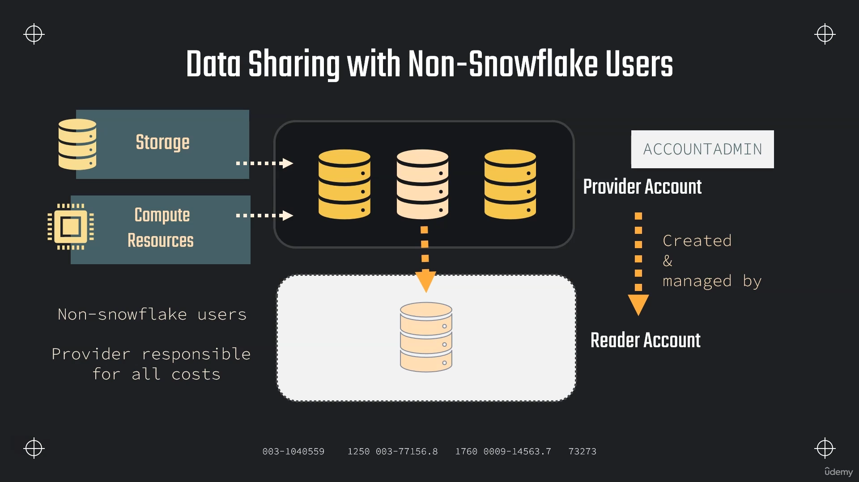

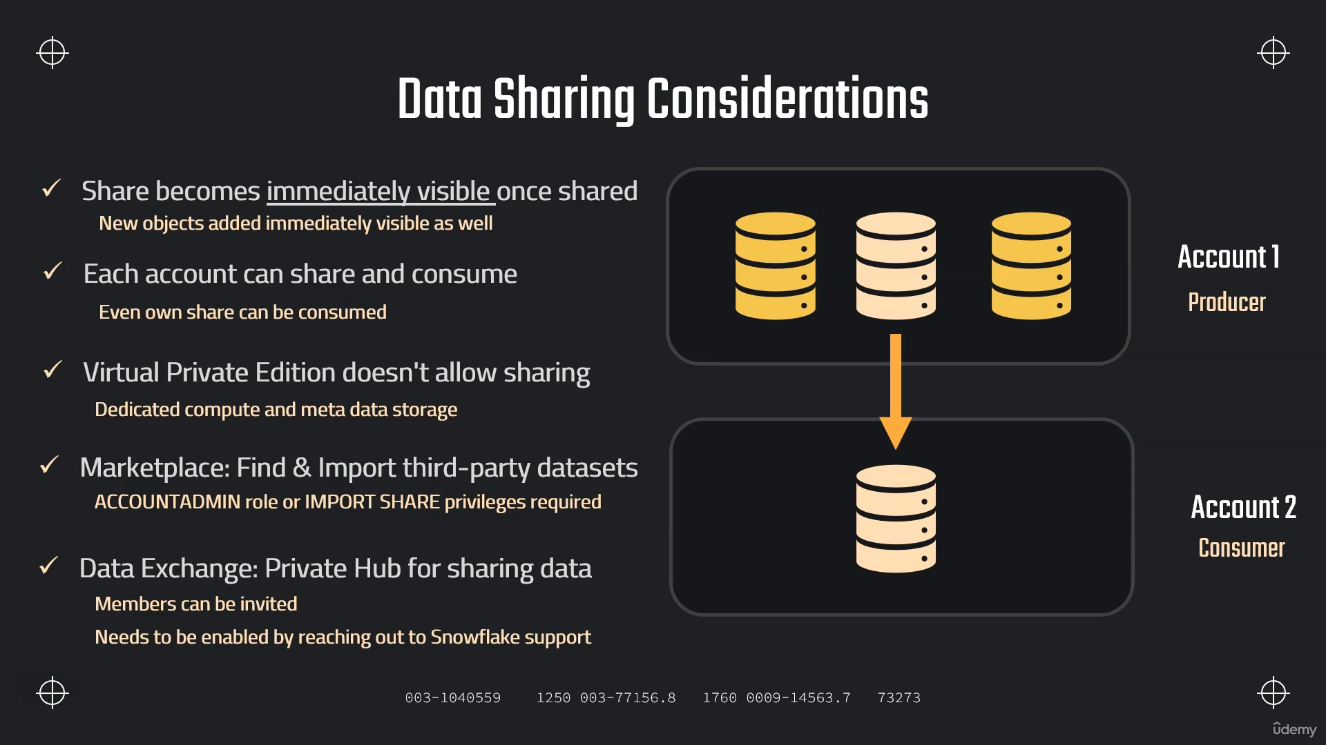

**Creating Reader Account**

**-- Create Reader Account --**

**CREATE MANAGED ACCOUNT tech_joy_account**

**ADMIN_NAME = krishna_admin,**

**ADMIN_PASSWORD = '14A98765a',**

**TYPE = READER;**

**// Make sure to have selected the role of accountadmin**

**// Show accounts**

**SHOW MANAGED ACCOUNTS;**

**-- Share the data --**

**ALTER SHARE ORDERS_SHARE**

**ADD ACCOUNT = FYB82954;**

**ALTER SHARE ORDERS_SHARE**

**ADD ACCOUNT = FYB82954**

**SHARE_RESTRICTIONS=false;**

**-- Create database from share --**

**// Show all shares (consumer & producers)**

**SHOW SHARES;**

**// See details on share**

**DESC SHARE ARGROCN.EQB12400.ORDERS_SHARE;**

**// Create a database in consumer account using the share**

**CREATE DATABASE DATA_SHARE_DB FROM SHARE ARGROCN.EQB12400.ORDERS_SHARE;**

**// Validate table access**

**SELECT * FROM DATA_SHARE_DB.PUBLIC.ORDERS;**

**// Setup virtual warehouse**

**CREATE WAREHOUSE READ_WH WITH**

**WAREHOUSE_SIZE='X-SMALL'**

**AUTO_SUSPEND = 180**

**AUTO_RESUME = TRUE**

**INITIALLY_SUSPENDED = TRUE;**

**-- Create and set up users --**

**// Create user**

**CREATE USER MYRIAM PASSWORD = 'difficult_passw@ord=123';**

**// Grant usage on warehouse**

**GRANT USAGE ON WAREHOUSE READ_WH TO ROLE PUBLIC;**

**// Grating privileges on a Shared Database for other users**

**GRANT IMPORTED PRIVILEGES ON DATABASE DATA_SHARE_DB TO REOLE PUBLIC**

**To login above User go to Account->click on tick mark account then click on copy symbol then paste url into new browser and login with userid and password above mentioned while creating user.**

**Sharing Database and Schema**

**SHOW SHARES;**

**// Create share object**

**CREATE OR REPLACE SHARE COMEPLETE_SCHEMA_SHARE;**

**// Grant usage on dabase & schema**

**GRANT USAGE ON DATABASE OUR_FIRST_DB TO SHARE COMEPLETE_SCHEMA_SHARE;**

**GRANT USAGE ON SCHEMA OUR_FIRST_DB.PUBLIC TO SHARE COMEPLETE_SCHEMA_SHARE;**

**// Grant select on all tables**

**GRANT SELECT ON ALL TABLES IN SCHEMA OUR_FIRST_DB.PUBLIC TO SHARE COMEPLETE_SCHEMA_SHARE;**

**GRANT SELECT ON ALL TABLES IN DATABASE OUR_FIRST_DB TO SHARE COMEPLETE_SCHEMA_SHARE;**

**// Add account to share**

**ALTER SHARE COMEPLETE_SCHEMA_SHARE**

**ADD ACCOUNT=KAA74702;**

**// Updating data**

**UPDATE OUR_FIRST_DB.PUBLIC.ORDERS**

**SET PROFIT=0 WHERE PROFIT < 0;**

**// Add new table**

**CREATE TABLE OUR_FIRST_DB.PUBLIC.NEW_TABLE (ID int);**

**Secure View Vs Normal View**

**-- Create database & table --**

**CREATE OR REPLACE DATABASE CUSTOMER_DB;**

**CREATE OR REPLACE TABLE CUSTOMER_DB.public.customers (**

**id int,**

**first_name string,**

**last_name string,**

**email string,**

**gender string,**

**Job string,**

**Phone string);**

**// Stage and file format**

**CREATE OR REPLACE FILE FORMAT MANAGE_DB.file_formats.csv_file**

**type = csv**

**field_delimiter = ','**

**skip_header = 1;**

**CREATE OR REPLACE STAGE MANAGE_DB.external_stages.time_travel_stage**

**URL = 's3://data-snowflake-fundamentals/time-travel/'**

**file_format = MANAGE_DB.file_formats.csv_file;**

**LIST @MANAGE_DB.external_stages.time_travel_stage;**

**// Copy data and insert in table**

**COPY INTO CUSTOMER_DB.public.customers**

**FROM @MANAGE_DB.external_stages.time_travel_stage**

**files = ('customers.csv');**

**SELECT * FROM CUSTOMER_DB.PUBLIC.CUSTOMERS;**

**-- Create VIEW --**

**CREATE OR REPLACE VIEW CUSTOMER_DB.PUBLIC.CUSTOMER_VIEW AS**

**SELECT**

**FIRST_NAME,**

**LAST_NAME,**

**EMAIL**

**FROM CUSTOMER_DB.PUBLIC.CUSTOMERS**

**WHERE JOB != 'DATA SCIENTIST';**

**-- Grant usage & SELECT --**

**GRANT USAGE ON DATABASE CUSTOMER_DB TO ROLE PUBLIC;**

**GRANT USAGE ON SCHEMA CUSTOMER_DB.PUBLIC TO ROLE PUBLIC;**

**GRANT SELECT ON TABLE CUSTOMER_DB.PUBLIC.CUSTOMERS TO ROLE PUBLIC;**

**GRANT SELECT ON VIEW CUSTOMER_DB.PUBLIC.CUSTOMER_VIEW TO ROLE PUBLIC;**

**SHOW VIEWS LIKE '%CUSTOMER%';**

**-- Create SECURE VIEW --**

**CREATE OR REPLACE SECURE VIEW CUSTOMER_DB.PUBLIC.CUSTOMER_VIEW_SECURE AS**

**SELECT**

**FIRST_NAME,**

**LAST_NAME,**

**EMAIL**

**FROM CUSTOMER_DB.PUBLIC.CUSTOMERS**

**WHERE JOB != 'DATA SCIENTIST' ;**

**GRANT SELECT ON VIEW CUSTOMER_DB.PUBLIC.CUSTOMER_VIEW_SECURE TO ROLE PUBLIC;**

**SHOW VIEWS LIKE '%CUSTOMER%';**

**Secure View->definition will not show**

**Normal View->Definition will show**

**Sharing Secure View**

**SHOW SHARES;**

**// Create share object**

**CREATE OR REPLACE SHARE VIEW_SHARE;**

**// Grant usage on dabase & schema**

**GRANT USAGE ON DATABASE CUSTOMER_DB TO SHARE VIEW_SHARE;**

**GRANT USAGE ON SCHEMA CUSTOMER_DB.PUBLIC TO SHARE VIEW_SHARE;**

**// Grant select on view**

**GRANT SELECT ON VIEW CUSTOMER_DB.PUBLIC.CUSTOMER_VIEW TO SHARE VIEW_SHARE;**

**Alter share View_share set secure_objects_only=true;**

**GRANT SELECT ON VIEW CUSTOMER_DB.PUBLIC.CUSTOMER_VIEW_SECURE TO SHARE VIEW_SHARE;**

**// Add account to share**

**ALTER SHARE VIEW_SHARE**

**ADD ACCOUNT=KAA74702;**

**Share data from multiple databases :-**

**CREATE SECURE VIEW SECURE_VIEW_M AS**

**SELECT**

**T1.ID,**

**T1.FIRST_NAME,**

**T2.JOB**

**FROM CUSTOMER_DB.PUBLIC.CUSTOMERS T1**

**INNER JOIN OUR_FIRST_DB.PUBLIC.CUSTOMERS T2**

**ON T1.ID = T2.ID;**

**SELECT * FROM SECURE_VIEW_M;**

**SHOW SHARES;**

**// Create share object**

**CREATE OR REPLACE SHARE VIEW_SHARE;**

**// Grant usage on dabase & schema**

**GRANT USAGE ON DATABASE CUSTOMER_DB TO SHARE VIEW_SHARE;**

**GRANT USAGE ON SCHEMA CUSTOMER_DB.PUBLIC TO SHARE VIEW_SHARE;**

**GRANT REFERENCE_USAGE ON DATABASE OUR_FIRST_DB TO SHARE VIEW_SHARE;**

**// Grant select on view**

**GRANT SELECT ON VIEW CUSTOMER_DB.PUBLIC.SECURE_VIEW_M TO SHARE VIEW_SHARE;**

**GRANT SELECT ON VIEW CUSTOMER_DB.PUBLIC.CUSTOMER_VIEW_SECURE TO SHARE VIEW_SHARE;**

**alter share VIEW_SHARE**

**set secure_objects_only = false;**

**// Add account to share**

**ALTER SHARE VIEW_SHARE**

**ADD ACCOUNT=OW45605;**

**Data Sampling :-**

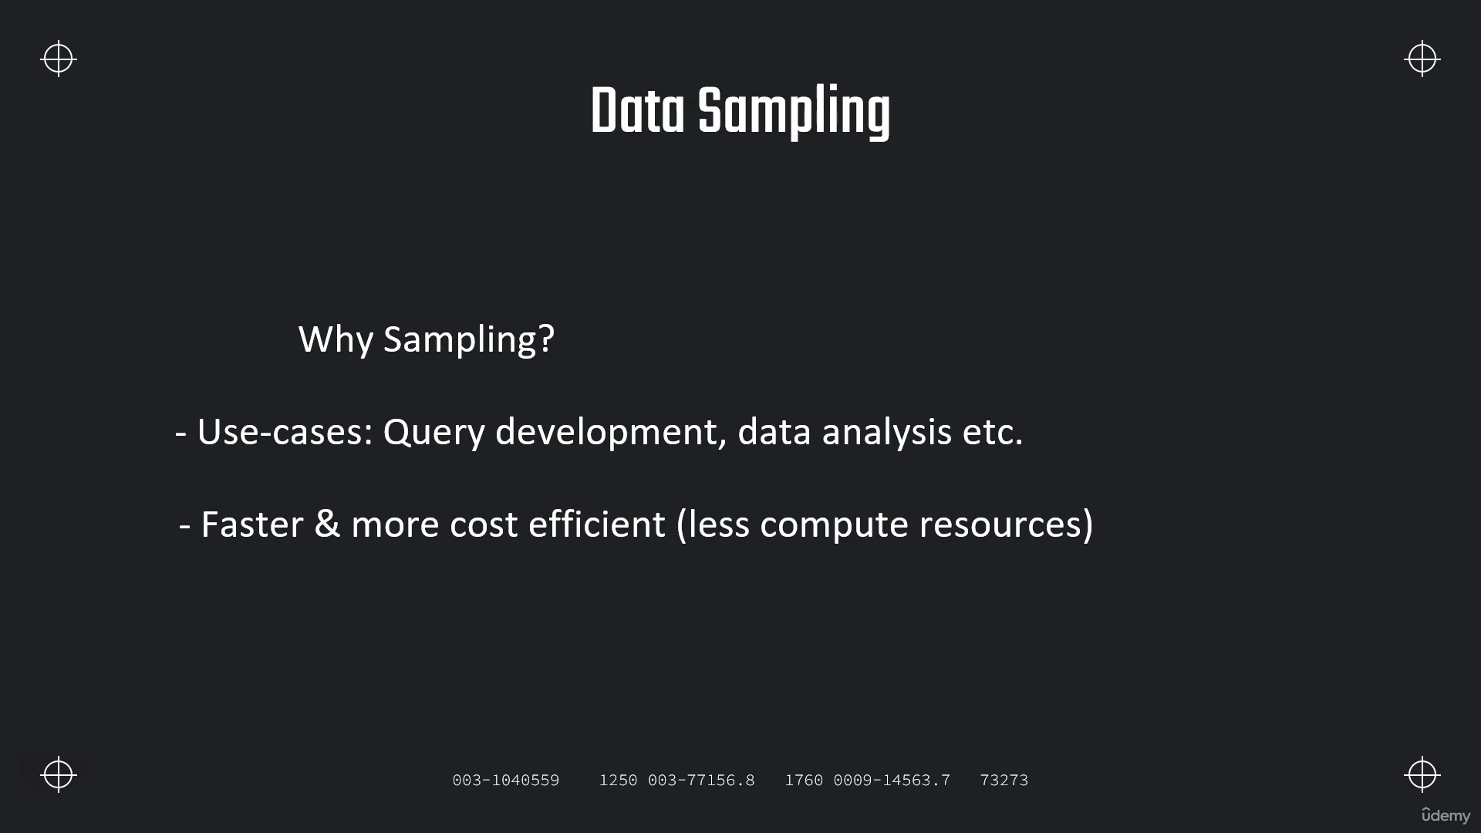

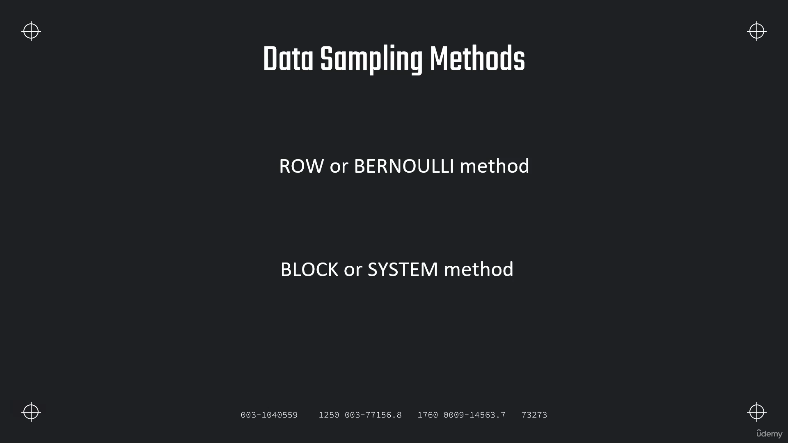

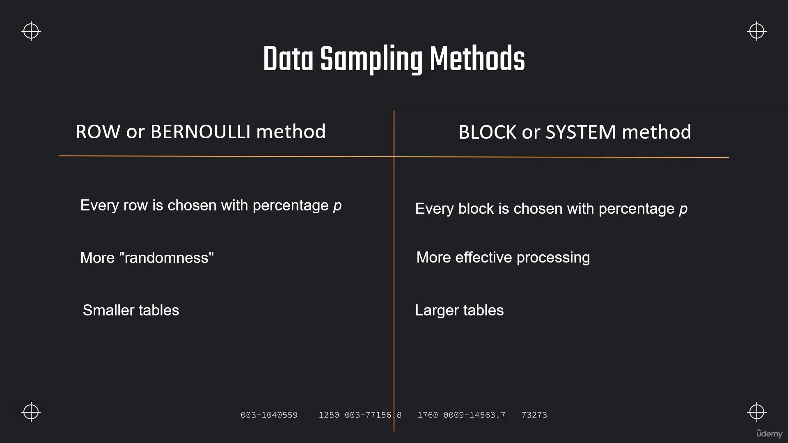

**CREATE OR REPLACE TRANSIENT DATABASE SAMPLING_DB;**

**CREATE OR REPLACE VIEW ADDRESS_SAMPLE**

**AS**

**SELECT * FROM SNOWFLAKE_SAMPLE_DATA.TPCDS_SF10TCL.CUSTOMER_ADDRESS**

**SAMPLE ROW (1) SEED(27);**

**SELECT * FROM ADDRESS_SAMPLE;**

**SELECT CA_LOCATION_TYPE, COUNT(*)/3254250*100**

**FROM ADDRESS_SAMPLE**

**GROUP BY CA_LOCATION_TYPE;**

**SELECT * FROM SNOWFLAKE_SAMPLE_DATA.TPCDS_SF10TCL.CUSTOMER_ADDRESS**

**SAMPLE SYSTEM (1) SEED(23);**

**SELECT * FROM SNOWFLAKE_SAMPLE_DATA.TPCDS_SF10TCL.CUSTOMER_ADDRESS**

**SAMPLE SYSTEM (10) SEED(23);**

**Assignment**

**Sample 5% from the table *"SNOWFLAKE_SAMPLE_DATA"."TPCDS_SF10TCL"."CUSTOMER_ADDRESS"*Use the ROW method and seed(2) to get a reproducible result.  
Store the result in the DEMO_DB in a table called CUSTOMER_ADDRESS_SAMPLE_5.**

**2. Sample 1% from the table *"SNOWFLAKE_SAMPLE_DATA"."TPCDS_SF10TCL"."CUSTOMER"***

**Use the SYSTEM method and seed(2) to get a reproducible result.  
Store the result in the DEMO_DB in a table called CUSTOMER_SAMPLE_1.**

**USE DEMO_DB;**

**CREATE TABLE CUSTOMER_ADDRESS_SAMPLE_5 AS**

**SELECT * FROM "SNOWFLAKE_SAMPLE_DATA"."TPCDS_SF10TCL"."CUSTOMER_ADDRESS"**

**SAMPLE ROW(5) SEED(2);**

**USE DEMO_DB;**

**CREATE TABLE CUSTOMER_SAMPLE_1 AS**

**SELECT * FROM "SNOWFLAKE_SAMPLE_DATA"."TPCDS_SF10TCL"."CUSTOMER" SAMPLE SYSTEM(1) SEED(2);**

**Scheduling Tasks :-**

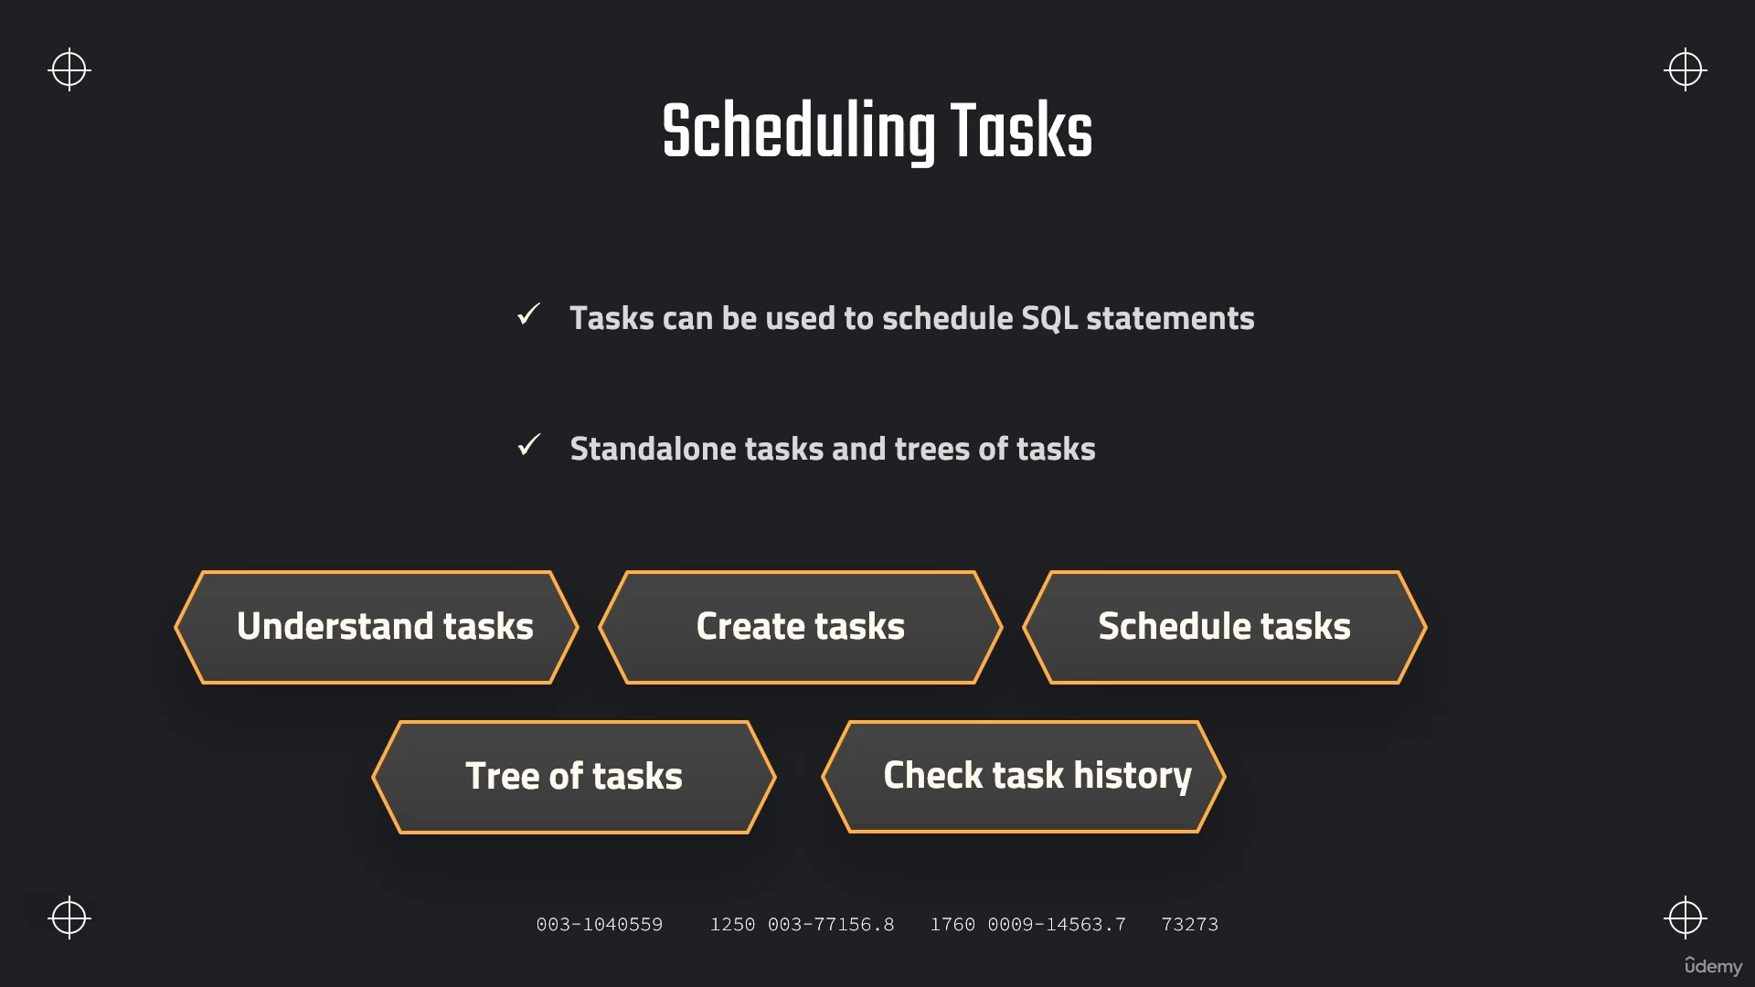

**Creating Tasks :**

**CREATE OR REPLACE TRANSIENT DATABASE TASK_DB;**

**// Prepare table**

**CREATE OR REPLACE TABLE CUSTOMERS (**

**CUSTOMER_ID INT AUTOINCREMENT START = 1 INCREMENT =1,**

**FIRST_NAME VARCHAR(40) DEFAULT 'JENNIFER' ,**

**CREATE_DATE DATE);**

**// Create task**

**CREATE OR REPLACE TASK CUSTOMER_INSERT**

**WAREHOUSE = COMPUTE_WH**

**SCHEDULE = '1 MINUTE'**

**AS**

**INSERT INTO CUSTOMERS(CREATE_DATE) VALUES(CURRENT_TIMESTAMP);**

**SHOW TASKS;**

**// Task starting and suspending**

**ALTER TASK CUSTOMER_INSERT RESUME;**

**ALTER TASK CUSTOMER_INSERT SUSPEND;**

**SELECT * FROM CUSTOMERS;**

**Using Cron :-**

**CREATE OR REPLACE TASK CUSTOMER_INSERT**

**WAREHOUSE = COMPUTE_WH**

**SCHEDULE = 'USING CRON 0 7,10 * * 5L UTC'**

**AS**

**INSERT INTO CUSTOMERS(CREATE_DATE) VALUES(CURRENT_TIMESTAMP);**

**# __________ minute (0-59)**

**# | ________ hour (0-23)**

**# | | ______ day of month (1-31, or L)**

**# | | | ____ month (1-12, JAN-DEC)**

**# | | | | __ day of week (0-6, SUN-SAT, or L)**

**# | | | | |**

**# | | | | |**

**# * * * * \***

**// Every minute**

**SCHEDULE = 'USING CRON * * * * * UTC';**

**// Every day at 6am UTC timezone**

**SCHEDULE = 'USING CRON 0 6 * * * UTC';**

**// Every hour starting at 9 AM and ending at 5 PM on Sundays**

**SCHEDULE = 'USING CRON 0 9-17 * * SUN America/Los_Angeles';**

**CREATE OR REPLACE TASK CUSTOMER_INSERT**

**WAREHOUSE = COMPUTE_WH**

**SCHEDULE = 'USING CRON 0 9,17 * * * UTC'**

**AS**

**INSERT INTO CUSTOMERS(CREATE_DATE) VALUES(CURRENT_TIMESTAMP);**

**Tree of Tasks**

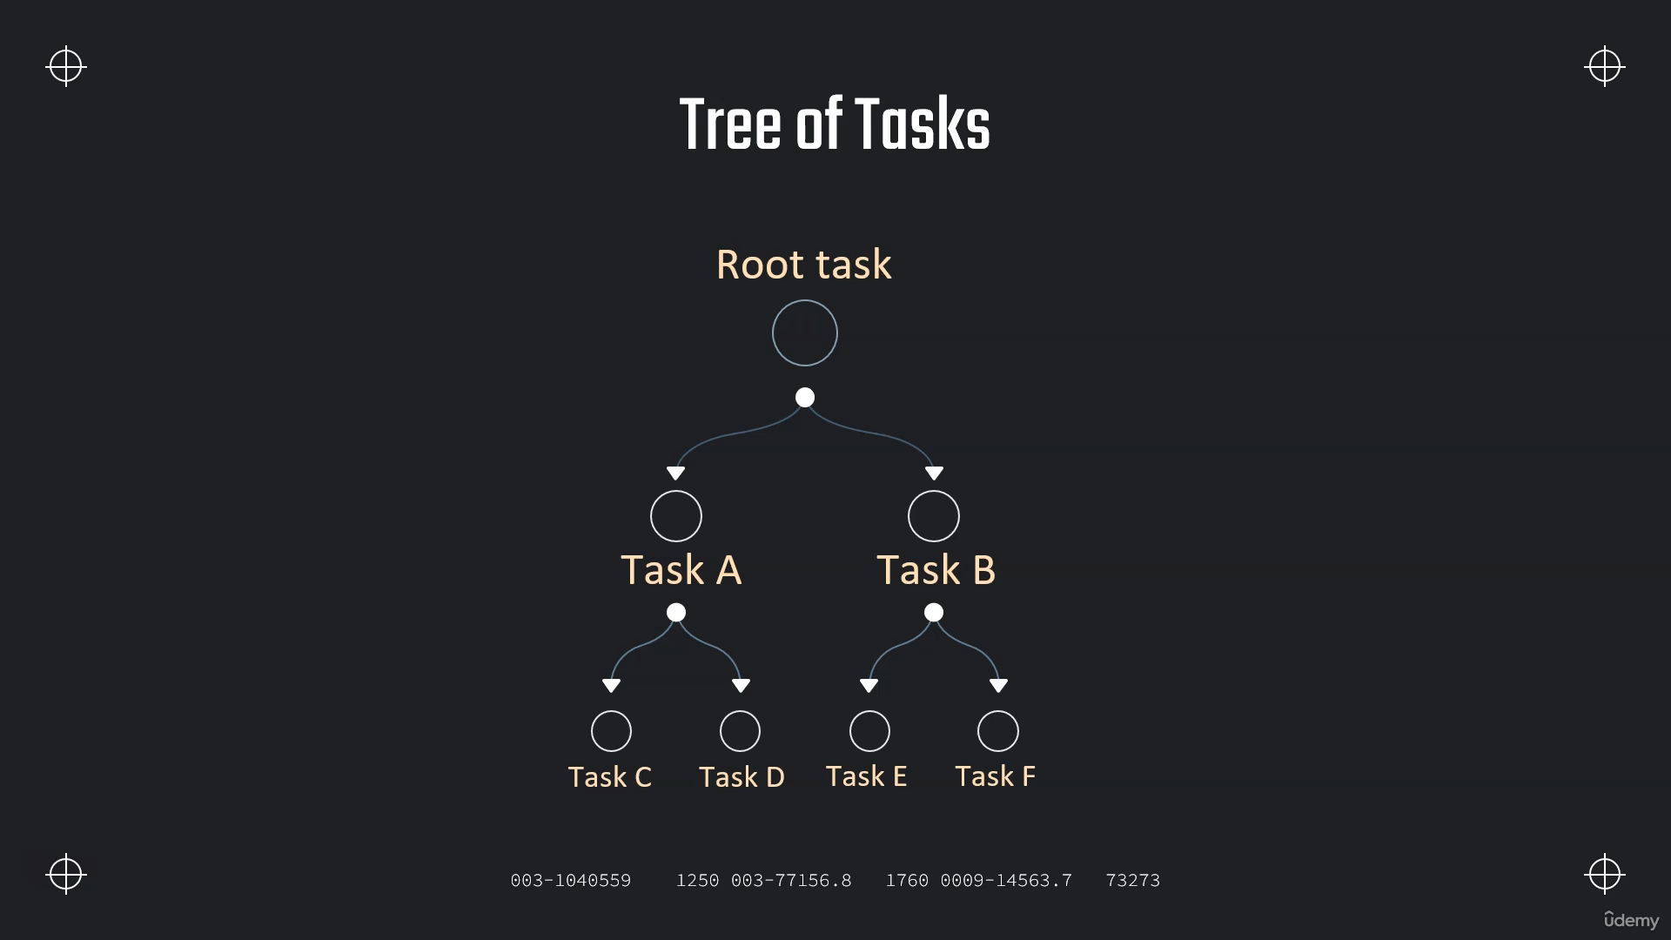

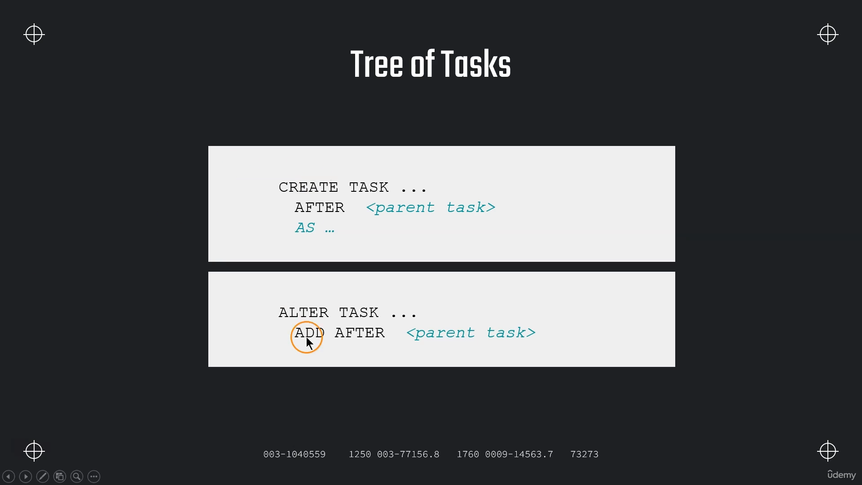

**Creating tree of tasks**

**USE TASK_DB;**

**SHOW TASKS;**

**SELECT * FROM CUSTOMERS;**

**// Prepare a second table**

**CREATE OR REPLACE TABLE CUSTOMERS2 (**

**CUSTOMER_ID INT,**

**FIRST_NAME VARCHAR(40),**

**CREATE_DATE DATE);**

**// Suspend parent task**

**// **NOTE: Before modifying anything in the tree of tasks the root task needs to be suspended\*\***

**ALTER TASK CUSTOMER_INSERT3 SUSPEND;**

**// Create a child task**

**CREATE OR REPLACE TASK CUSTOMER_INSERT2**

**WAREHOUSE = COMPUTE_WH**

**AFTER CUSTOMER_INSERT**

**AS**

**INSERT INTO CUSTOMERS2 SELECT * FROM CUSTOMERS;**

**// Prepare a third table**

**CREATE OR REPLACE TABLE CUSTOMERS3 (**

**CUSTOMER_ID INT,**

**FIRST_NAME VARCHAR(40),**

**CREATE_DATE DATE,**

**INSERT_DATE DATE DEFAULT DATE(CURRENT_TIMESTAMP));**

**// Create a child task**

**CREATE OR REPLACE TASK CUSTOMER_INSERT3**

**WAREHOUSE = COMPUTE_WH**

**AFTER CUSTOMER_INSERT2**

**AS**

**INSERT INTO CUSTOMERS3 (CUSTOMER_ID,FIRST_NAME,CREATE_DATE)**

**SELECT * FROM CUSTOMERS2;**

**SHOW TASKS;**

**ALTER TASK CUSTOMER_INSERT**

**SET SCHEDULE = '1 MINUTE';**

**// Resume tasks (first resume child tasks)**

**ALTER TASK CUSTOMER_INSERT3 RESUME;**

**ALTER TASK CUSTOMER_INSERT2 RESUME;**

**// Resume tasks (then resume root task)**

**ALTER TASK CUSTOMER_INSERT RESUME;**

**// Recursively resumes a specified task and all its dependent tasks**

**SELECT SYSTEM$TASK_DEPENDENTS_ENABLE( 'CUSTOMER_INSERT' );**

**SHOW TASKS;**

**SELECT * FROM CUSTOMERS2;**

**SELECT * FROM CUSTOMERS3;**

**// Suspend tasks again**

**ALTER TASK CUSTOMER_INSERT SUSPEND;**

**ALTER TASK CUSTOMER_INSERT2 SUSPEND;**

**ALTER TASK CUSTOMER_INSERT3 SUSPEND;**

**Calling A Stored Procedure :-**

**// Create a stored procedure**

**USE TASK_DB;**

**SELECT * FROM CUSTOMERS;**

**CREATE OR REPLACE PROCEDURE CUSTOMERS_INSERT_PROCEDURE (CREATE_DATE varchar)**

**RETURNS STRING NOT NULL**

**LANGUAGE JAVASCRIPT**

**AS**

**$$**

**var sql_command = 'INSERT INTO CUSTOMERS(CREATE_DATE) VALUES(:1);'**

**snowflake.execute(**

**{**

**sqlText: sql_command,**

**binds: [CREATE_DATE]**

**});**

**return "Successfully executed.";**

**$$;**

**CREATE OR REPLACE TASK CUSTOMER_TAKS_PROCEDURE**

**WAREHOUSE = COMPUTE_WH**

**SCHEDULE = '1 MINUTE'**

**AS CALL CUSTOMERS_INSERT_PROCEDURE (CURRENT_TIMESTAMP);**

**SHOW TASKS;**

**ALTER TASK CUSTOMER_TAKS_PROCEDURE RESUME;**

**SELECT * FROM CUSTOMERS;**

**Task History and Error Handling :-**

**SHOW TASKS;**

**USE DEMO_DB;**

**// Use the table function "TASK_HISTORY()"**

**select \***

**from table(information_schema.task_history())**

**order by scheduled_time desc;**

**// See results for a specific Task in a given time**

**select \***

**from table(information_schema.task_history(**

**scheduled_time_range_start=>dateadd('hour',-4,current_timestamp()),**

**result_limit => 5,**

**task_name=>'CUSTOMER_INSERT2'));**

**// See results for a given time period**

**select \***

**from table(information_schema.task_history(**

**scheduled_time_range_start=>to_timestamp_ltz('2021-04-22 11:28:32.776 -0700'),**

**scheduled_time_range_end=>to_timestamp_ltz('2021-04-22 11:35:32.776 -0700')));**

**SELECT TO_TIMESTAMP_LTZ(CURRENT_TIMESTAMP) ;**

**Task with Condition**

